Rich Media e Learning Content
Anil Ripla
Ray Consulting Limited, Chaguanas, Trinidad and Tobago, rcl@rayconsultingtt.com.
Abstract
This paper seeks to outline the various types of media that can be used to develop an e learning application that will provide a rich and compelling learning experience to users. The use of text, images, animations, videos, serious games, learning objects and web-based learning management systems will be explored. The key processes of developing the media are also described. The illustrations and samples of media contained in this paper are part of e learning applications developed by the author for purposes of providing training to the public.
TYPES OF MEDIA CONTENT
The following are some of the key types of media that may be used in developing an e learning application:
Text
As in traditional training materials, text is used to convey information to the learners.
Images
Images may include photos or illustrations to provide learners with visual representations to reinforce text descriptions or to support the explanation of facts or concepts.
Animation
Animation is a series of moving illustrated images that provide learners with a visual presentation of moving objects and persons.
Videos
A Video is a moving sequence of still photographs to provide learners with a visual presentation of moving object and persons.
Serious Game
A serious game is a programme developed with gaming principles and technology with a primary purpose of delivering learning through an interactive computer game environment
Learning Object
A learning object is a modular component that can be re-used in several different e learning applications.
Learning Management System
The learning management system is used to deliver a packaged e learning system and track assessments and other data generated from the learning process.
In the following section we will be looking at samples of these various media in an implemented e learning application.
TEXT
Text is used to provide information to the learners in a similar fashion to traditional text books. The main difference in e learning is that text is presented in an electronic media rather than a printed media. Hyper Text Markup Language (HTML) is predominantly used to display text in a web-based interface such as a web browser. This allows learners to read training materials over the internet or from a CD by use of a web-browser. HTML is developed using a web design software.

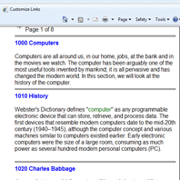
Figure 1. Text. Text displayed in a web browser using
the HTML protocol
IMAGES
Images can comprise of still photographs or illustrations. They are used to reinforce text descriptions or to support explanations of facts or concepts. Images should be in a format that can be displayed in a web browser. The common formats for images are .gif, .jpeg and .png.
Images can be captured with digital cameras, accessed from stock photos on the web or developed from illustration software. Images can be edited using digital imaging software programmes. The software will also format the images for the web by reducing the file size to ensure the fast loading of web pages. File sizes are important when using images on a web page. Large file sizes will cause web pages to take longer to load in the browser and this can be an annoyance to the learner.
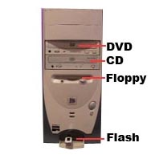
Figure 2. Image.
Image used to reinforce and illustrate text descriptions.

ANIMATION
Animation is a sequence of moving still images. The process of animation is comprised of modeling and key frame animation which are both created in a 3D design application.
A 3D model is a geometrical representation of an object. 3D models contain textures and shading that provide surface effects to the 3D objects.
After the 3D models are created, an animation sequence is developed. The animation sequence is comprised of a series of image frames where the 3D model’s position or geometry is subtly modified for every subsequent frame to provide the effect of motion when each frame is viewed in sequence. Several frames are created for each animation sequence. The process of developing several frames that are viewed in sequence to provide the effect of motion is termed key frame animation.

Another key aspect in animation is bones animation. This is especially important when developing human motion. In bones animation, the motion of a human or jointed object is generated by the software applications through the use of mathematical algorithms. Inverse kinematics is an important method for the application of algorithms to determine the movements of each connected joint in body to achieve a specified end point pose. Inverse kinematics is commonly used to animate human objects or any jointed object with an underlining bones structure.
Lighting in animation provides additional realism to the animation sequence. The position of lights and light characteristics, e.g. luminosity, are specified to achieve a desired effect.
Narration may be included in an animation sequence to describe actions in the animation and to increase learner attention and interest.
Animation is an extensive process and it may take several hours or days to produce a single animation sequence. A typical e leaning application may contain 50-100 animation sequences.
Rendering is the process of outputting the animation sequence to a format that will play as a movie in a web browser. The rendering process may be long depending on the detail of the animation. It is not uncommon for the rendering to take several hours for a singe animation sequence. Common output formats for animation include .avi or .mpeg. A movie player will be required to play animated movies in a browser.
Animation file sizes are quite large, normally several mega bytes. Those with a slow internet connection, viewing animation can be very problematic due to the time required to load the files. This can lead to learner annoyance. E learning applications that contain extensive animations should be delivered over a broadband internet connection or any similar connection with fast internet speeds. As an alternative, e learning can be delivered via CDs on the user’s local computer. In this way, loading and playing animation are not problematic and users are not subjected to the relatively high level of annoyance experienced with a low speed internet connection.

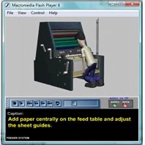
Figure 3. Animation.
A rendered animation sequence being played as a movie
in a web browser

VIDEOS
Videos provide learners with a visual appreciation of concepts being presented in a learning package. Videos, like animation provides a very rich learning experience.
Videos are normally created with the use of a digital video recorder. The video files can be saved in several formats, .avi or .mpeg formats are very common. The raw video feed once shot, has to be edited. This is done using a video editing programme. In the video editing programme, the video can be edited or text and other annotations can be added to the video. Once the video editing is completed, the video may be narrated. The completed video will be published in a format that can be played as a movie in a web browser. Common formats include .avi or .mpeg.

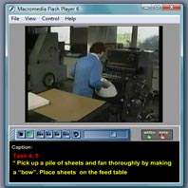
Figure 4. Video.
A video playing in a web browser
SERIOUS GAMES
A serious game is developed based on gaming technology and processes. Serious games are similar in nature to video games but are geared towards teaching. Serious games are interactive and require the user to manipulate game objects with the mouse, key board or joy stick.
The first step in developing a game is to develop 3D models for the game using a modeling software programme. Once the models are created, a game engine is used to develop the gaming interactions. The interactions are usually programmed using the game engines programming language, such as java, C++, lingo, etc. Gaming interaction includes moving, rotating, zooming and otherwise interacting with 3D models. The game engine may also provide additional algorithms for physics, such as gravity, collision detection, explosions, etc. Games are developed in a sequence of levels or stages. A user will be required to complete one or more objectives in a game level. After achieving these objectives, users can proceed to the next game level. A single game level may take several hours or months to develop depending on the complexity of the level.
Gaming is very interactive, as well as, entertaining to users. Machine simulations based on gaming technology can be very effective in teaching learners how to operate equipment, such as flight simulation, crane simulation, etc.
Games can be published so that users can play them on the internet. One popular format for publishing games is the shockwave format, which will allow learners to play a game over the internet in the shockwave player.
Game files are quite large and can be annoying to play online for a learner with a slow internet connection. Games can be delivered via a CD on a user’s local computer in cases where there is a slow internet connection.
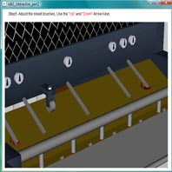|
Figure 5. Serious Game.
Serious Game being played in a web browser
teaching the operations of a printing press

LEARNING OBJECT
A learning object is a “ready made” component that can be re-used in different e learning applications. An example of a learning object is a quiz engine. The quiz engine is a useful template that can be used to quickly develop online exams. The developer simply has to specify the questions and answers in the quiz learning object. This saves the designer time since there is no need to design and code a quiz e learning application from scratch. Learning objects can drastically reduce the time to production for an e leaning application.
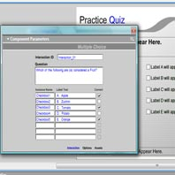
Figure 6. Learning Object.
A learning object being used to quickly develop a
multiple choice quiz

LEARNING MAMAGEMENT SYSTEM
A Learning Management System (LMS) is used for delivering and tracking training. The media content that was previously described may be packaged within a LMS that will constitute the e learning application. The LMS usually contains portals for students, teachers and administrators of the system. The LMS may also contain several database tables that track assessments, e.g., student grades in assignments or examinations.
In an e learning system, the LMS is a web-based interface that can be accessed on the web or from a CD. Generally the LMS will allow for the following actions:

Students can use the LMS to access the learning media such as text, images, videos, animations, etc. They may also take exams online and/or upload written assignments for marking by their teachers. Students may view the exam results online in the LMS.
Teachers can use the LMS to mark assignments online. They may also communicate with the students electronically in the LMS.
The administrator of the LMS will set the usernames and passwords for students and teachers to access their portals. Administrators may also maintain LMS databases. Some LMSs may be open source and can be customized by the administrators.

Figure 7. Leaning Management System (LMS)
A student portal in a LMS used to deliver training

CONCLUSION
In this paper, typical media content has been presented that designers may incorporate into their e learning application. These media included text, images, animation, videos, serious games, learning objects and learning management systems. The key processes of designing the media were also provided. Effective use of these media will provide the learner with a rich e learning experience that is both compelling and maintains the learner’s interest.

