Special Project Portal: A Case Study of a Customised Course Management System

Mr. Wayne Sarjusingh
The University of the West Indies, St. Augustine, Trinidad and Tobago, Wayne.Sarjusingh@sta.uwi.edu

Dr. Fernando Castellanos
The University of the West Indies, St. Augustine, Trinidad and Tobago, Fernando.Castellanos@sta.uwi.edu

Ms. Crista Mohammed
The University of the West Indies, St. Augustine, Trinidad and Tobago, Crista.Mohammed@sta.uwi.edu

Abstract

The ECNG 3020 - Special Project Portal is a custom-built, course management system, used in the Department of Electrical and Computer Engineering, The University of the West Indies (UWI), St. Augustine Campus. Given the specific management and administrative demands of the Final Year Project, the need for an e-solution was evident. Departmental resources, were mobilized to build the Portal with a view to improving the 2008/2009 ECNG 3020 offering and beyond. The Portal serves as: 1) a central hub for information, 2) an administrative and processes management platform and 3) a sharing tool.

End-user feedback was positive, and encouraging. Users rated highly the Portal’s function as a one-stop shop for course information and the project proposal provisions. The course administrator lauded the scheduling tools, which significantly reduced the effort needed to generate an array of schedules.

A customized course management tool does require significant initial outlay, both material and human. Using departmental advantages, namely software expertise and hardware, the Portal’s many facilities, tools and inherent adaptability justify this initial investment as it promises to serve the department for the long-term. Its greater potential is in its possible applicability in the management of other final year projects.

Keywords: UWI, ECNG 3020, customised course management system
INTRODUCTION

The ECNG 3020 - Special Project is regarded as the capstone course of the BSc in Electrical and Computer Engineering. It is a student-driven, research and development project that does not involve traditional course delivery and assessment. This course has an average enrolment of eighty (80) students, who are supervised by approximately fifteen (15) lecturers.

ECNG 3020 commands significant resources, administrative time and effort. Faculty may each supervise as many as ten (10) independent student projects. For students, ECNG 3020 is arguably the most critical and demanding course as it is a year-long, high-stakes assessment that counts for 6 credits and contributes 20% of the final weighted average used to determine the class of degree awarded.

Specific course needs and associated processes, which are not part of existing course management systems, such as WebCT and Moodle, necessitated the development of a customised management portal. The Special Project Portal was developed, by the authors of this paper, using open source software, to address these requirements. The Portal serves as: 1) a central hub for information and communication, 2) an administrative and process management platform and 3) an information sharing tool.

Simplicity and usability were guiding principles in the design of the Portal; keeping in mind that undue complexity could alienate users. The Portal thus presents a very gentle learning curve. Moreover, it makes various course processes easier for all parties – the course coordinator, examiners and students. And, it has been developed incrementally, as functionality was implemented in parallel with the needs of the actual course delivery, during the 2008/2009 academic year.

Using insiders’ knowledge this paper describes processes unique to ECNG 3020 which catalysed the development of the Portal. The Portal’s tools and provisions, the course web-portal design and challenges faced during the development are described. Evidence of usability, gleaned from two surveys, is presented. We explore the advantages and disadvantages of developing a customised course management system. Finally, it is intended that with subsequent ECNG 3020 offerings, the Portal will be enhanced and improved, so future plans are shared.

SERVING A COMMUNITY OF USERS

A significant suite of provisions serve the course coordinator. These processes include (1) publishing project proposals, (2) assigning projects to students, (3) scheduling presentations, (4) generating various course related documents, (5) sharing course information and (6) archiving data generated during a particular course offering.

For course participants the Portal allows them (1) ready access to course information, (2) access to published project proposals, (3) project proposal tools and (4) project selection options.

Project supervisors use the Portal (1) to draft, revise, submit and peer-review project proposals, (2) archive past proposals, (3) assign projects to students and (4) access course information.

ECNG 3020 PROCESSES AND PORTAL DEVELOPMENT

ECNG 3020 was initially coordinated using hardcopy forms that were exchanged amongst the coordinator, faculty and students. This manual, paper-based system was difficult to handle with normal problems related to missing forms, long delays in distribution and exchange of information, and difficulty in tracking information or changes. Subsequently, an electronic-based system was created using a combination of independent, static web pages and a standalone database administered by the coordinator. This system solved some of the problems in terms of broadcasting basic course information, collating some of the course data and creating a centralized data system. However, the lack of communication between the database and the web pages made for difficult handling and required tedious, repetitive work to feed and update the information in these two major components. Generic course management systems, such as WebCT and Moodle, were not considered useful given the unique requirements of ECNG 3020.

Based on past experience a decision was taken to create an Internet portal. The Portal has been designed as a system of linked, dynamic pages and forms that can interact with users and a database that collects, stores and manages course information. The Portal has to accommodate three types of users: the coordinator, project supervisors and students. Each user has very specific needs, with a small subset of these needs common to all.

The Portal was developed using the software prototyping model in which functionality was implemented fairly quickly and then iteratively refined until it performed satisfactorily. This model was chosen because it allows a basic prototype to be developed rapidly, enabling users to assess the relevance and usefulness at an early stage, well in-advance of significant investment in the development of a system that does not perform desirably.

The Portal was implemented using free, open-source software. The database was implemented using the MySQL database management system. Portal functionality was implemented using PHP server-side scripts and JavaScript client-side scripts. It was deployed on the Faculty of Engineering’s server, running the FreeBSD operating system and the Apache web server.

Creation and Publication of Project Proposals

Each course offering requires new project proposals. Both lecturers and final year students can propose projects. A standard form specifies required information for a comprehensive proposal. Typically, 6 - 8 project proposals are required from each supervisor resulting in 90 - 120 project proposals per academic year.

One of the most valuable tools in the Portal is the centralized system to create, store, review and publish the proposals. Lecturers can draft proposals and continuously review these using a simple editing tool embedded in the Portal, as shown in Figure 1. A completed proposal is submitted via the Portal, to the coordinator who takes it through the review process. The WYSIWYG functionality of the project proposal creation and editing tool was implemented using the TinyMCE JavaScript library.

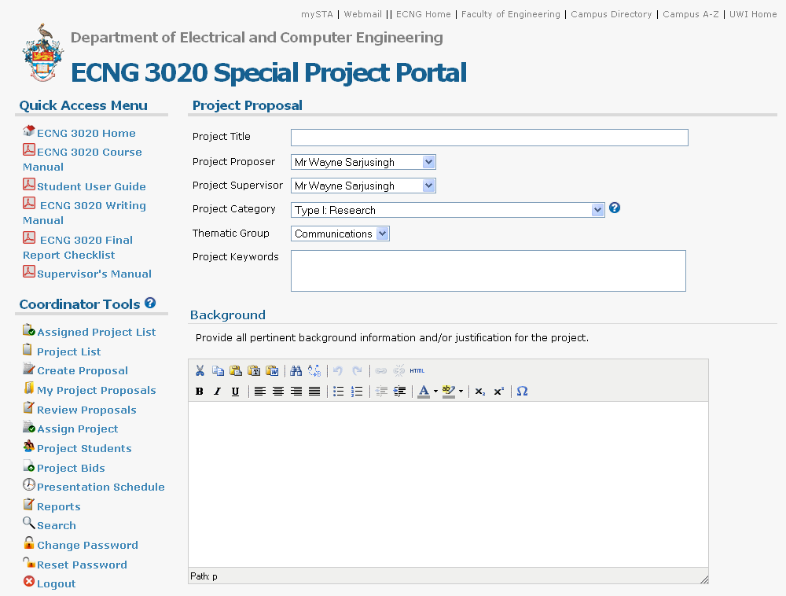

Figure 1. Project proposal creation and editing.

Approval of Project Proposals

All proposals must be approved before publishing. This ensures that proposals are of acceptable academic quality, sufficiently challenging and achievable over two semesters. A review process, undertaken by the Department’s thematic groups, evaluates and approves or suggests changes to proposals. Once a project is approved the coordinator indicates the change of status as shown in Figure 2.

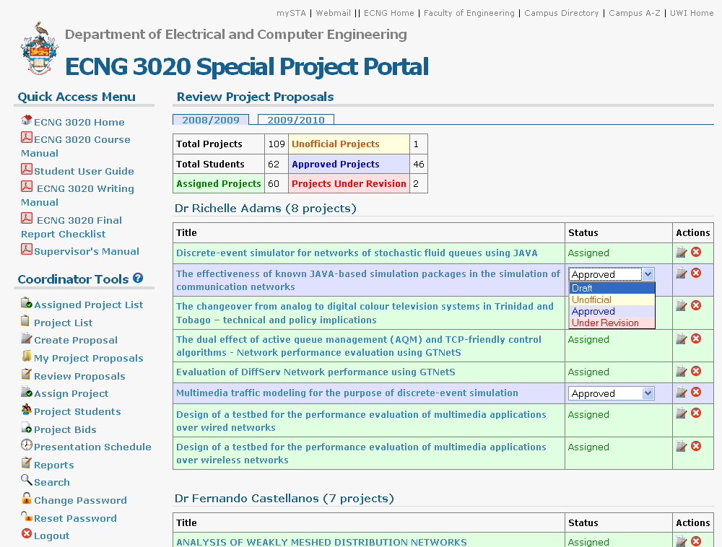

Figure 2. Project proposal approval.
Publishing of Approved Project List

Following the approval of proposals, the project list is dynamically generated and therefore automatically kept up to date and links to the full details of each project as shown in Figure 3.

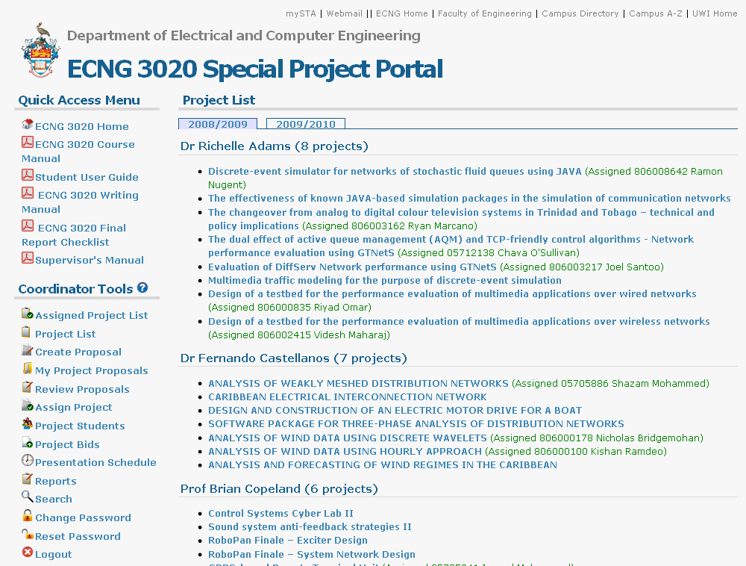

Figure 3. Approved project list.
Assignment of Projects

At the beginning of semester one, students can consult lecturers on project proposals. At this stage, supervisors, at their discretion, can assign their own projects to students. The lecturer simply selects the student from a list as shown in Figure 4. The automatic updating of the projects’ status is critical to informing students about those projects that remain unassigned and thus available. A record is kept of who assigned the project and the date and time of assignment; this log is useful for auditing purposes.

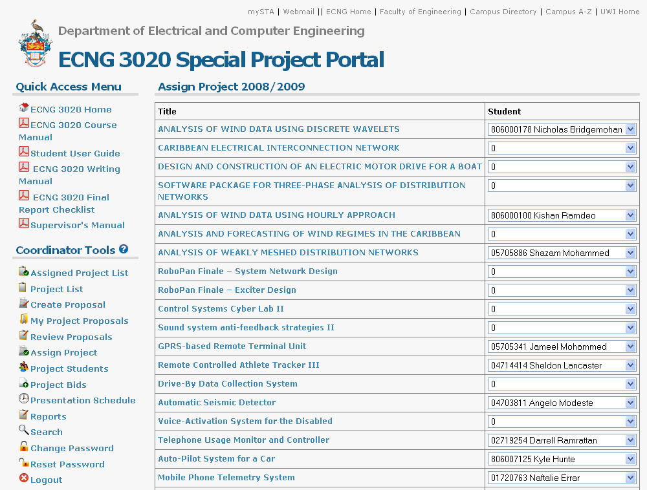

Figure 4. Project assignment.
Bidding for Projects

After the project assignment stage, students who have not yet secured a project can bid for the unassigned projects by selecting up to four projects as shown in Figure 5. The coordinator, in consultation with faculty, makes a final decision on the assignment of projects.

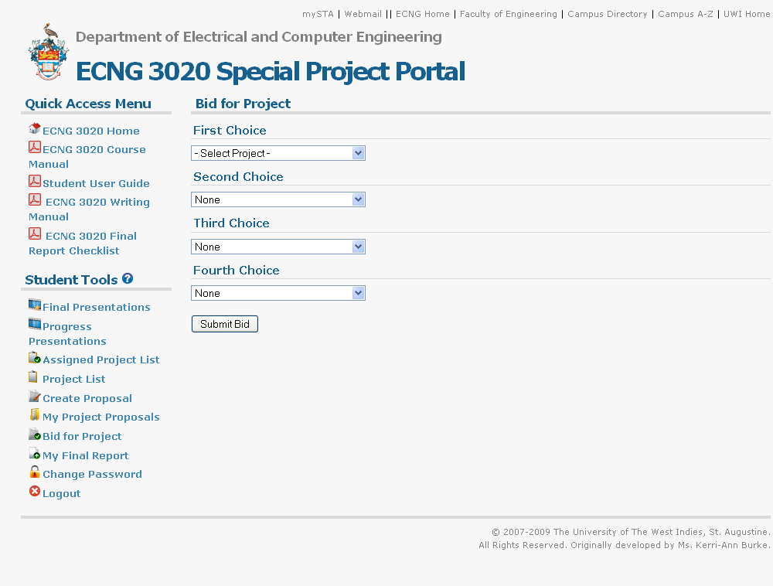

Figure 5. Project bidding.

Assigned Project List

After all students have been assigned, a list based on the project assignments is automatically generated as shown in Figure 6.

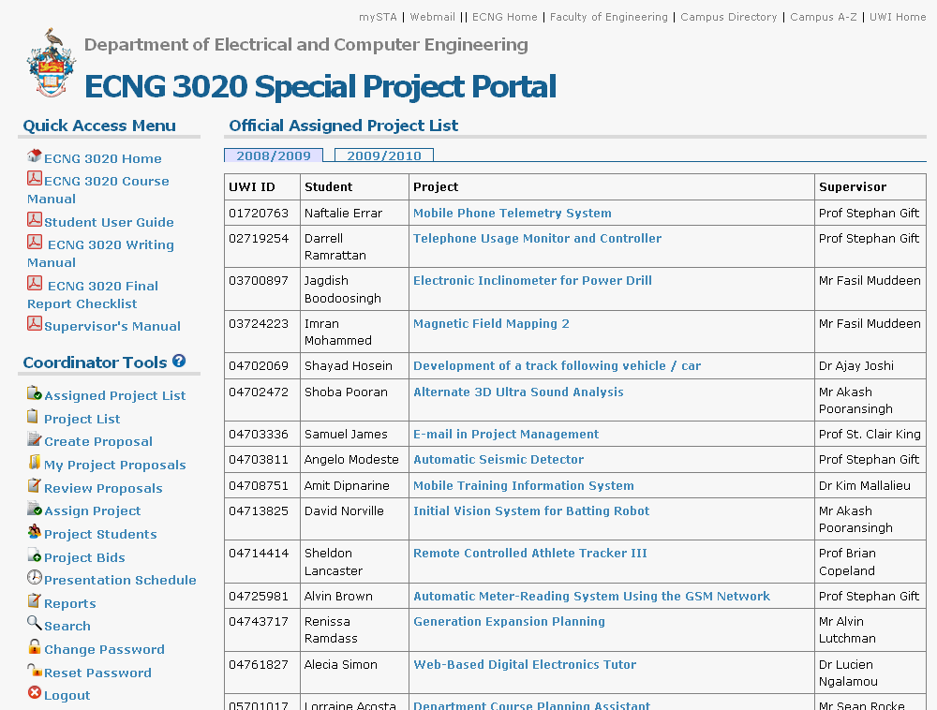

Figure 6. Assigned project list.

Progress and Final Presentations

Student presentations are held at two instances. The first is a progress presentation in January and the second is the final presentation in April. Four parallel sessions are hosted over two to four days, depending on course enrolment. ECNG 3020 presentations are evaluated by a panel consisting of the project supervisor, a second examiner and a moderator. Scheduling is a demanding task given the limited number of faculty and large student enrolment.

A scheduling tool, using drag and drop functionality, as shown in Figure 7 allows students, and examiners to be assigned to configurable time slots, hosted in four rooms. Post this, schedules by examiner, room and day are automatically generated and shared. The drag and drop functionality was implemented using the Prototype JavaScript framework and the Scriptaculous JavaScript library.

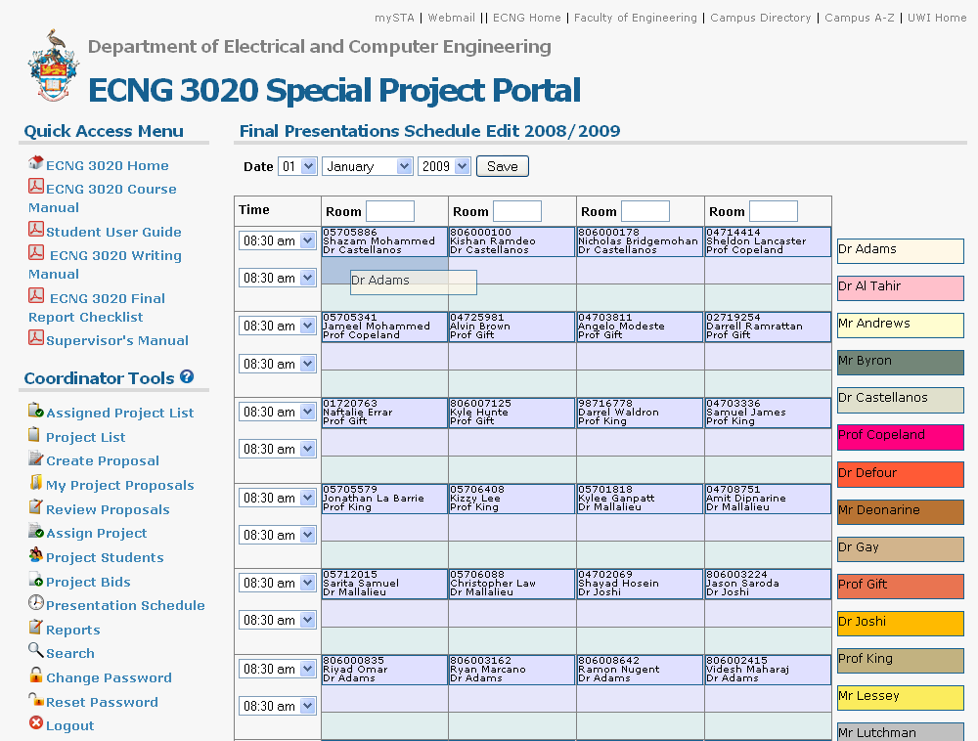

Figure 7. Presentation scheduling tool.

USER RECEPTION AND FEEDBACK

Abbitt (2006) identified that two major factors of user acceptance of a custom-made course management system were ease of navigation and visual perception, thus the study’s survey instruments aimed to test these. Using a Likert Scale, users rated the Portal’s usefulness for accessing information and its navigability. Faculty also assessed the usefulness of various tools, specific to their functions. In addition to close-ended questions, users provided qualitative feedback. In total, fifty-nine (59) persons, or 88% of the entire community of users was polled, this included both faculty and students.

To the credit of the Portal, the large majority of those polled, or 88%, found it a useful hub for accessing course related information (see Figure 8).

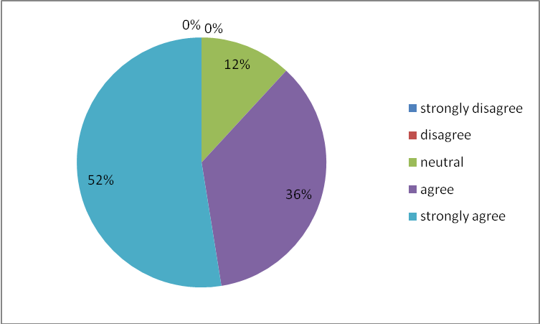
Figure 8: Responses to statement “The Portal was a useful resource for accessing information on ECNG 3020”

Most users, that is 90%, judged the Portal easy to use and navigate. Significantly, more than half or 54% of the sample strongly agreed that the Portal could be navigated and used easily (see Figure 9).

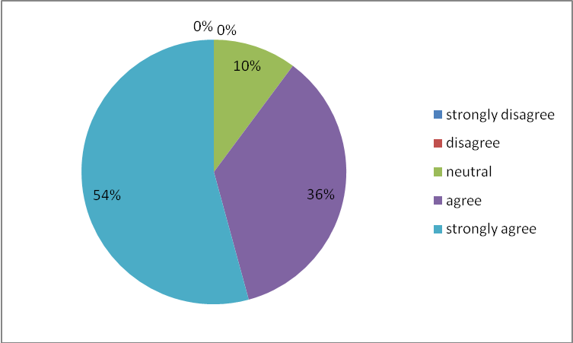
Figure 9: Responses to Statement “Portal was easy to use and navigate”

One underlying principle in the development of the Portal was that there must be improved access to information. Students were polled on how well they were able to view available project proposals. This information is vital to designers who want to ensure fair treatment of students in a process that involves great competition, as students do vie for projects. Most students, in excess of four-fifths of the sample, felt that they were able to easily view projects (see Figure 10). This is significant, since as projects are assigned, the updated list of available projects can be accessed in real-time allowing students to make informed decisions.

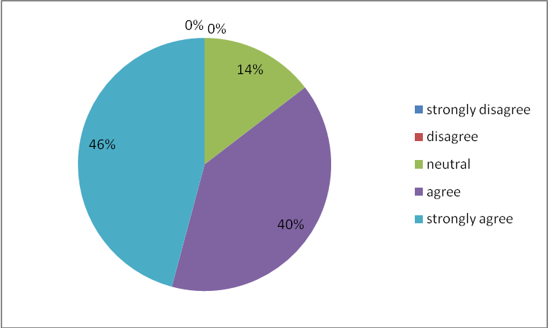
Figure 10: Responses to the statement “The Portal allowed for easy viewing of available projects”

Of those faculty members polled, many felt that the tools that allowed for creating proposals, managing proposals and assigning projects were the most useful. Two faculty members disagreed that the Portal’s proposal drafting and editing facility was simple to use. In one instance the examiner indicated that this facility proved challenging to the first time user. And in the second instance, that examiner experienced difficulty in navigating various versions of proposals, as multiple copies were created through the automatic save feature.

In their qualitative feedback, four (4) examiners were pleased that all course related information could be accessed from a central hub. In particular, one examiner felt that it was useful to browse other projects on offer. The coordinator expressed that this facility allows for easy, convenient peer review of projects – a process that is critical to ensuring quality proposals.

The coordinator selected the scheduling feature as most useful since it significantly reduced effort in the generation of several sets of schedules and reduced human error.

CHALLENGES AND REWARDS
A custom-made course management system requires a wide array of resources, chief being a dedicated software developer. Our department has a clear advantage, as our core business involves this precise type of research and development. The Portal demonstrates the department’s ability to maximise available resources to solve local problems. As added advantage the Portal testifies to our capacity to design and build software products.

A customized course management system as opposed to a commercial or open source one was preferred. It may be argued that open source course management systems can also be customized to suit user needs. However, this requires a thorough understanding of the organization and operation of the various sub-systems and the technical competence to implement these changes with a consistent look and feel that does not adversely affect other parts of the system.

The most significant advantage offered by a custom-built system is user targeted functionality. It directly addresses required features without unwanted facilities. Secondly, new system functionality can be more rapidly introduced since the system internals are already familiar and well understood. Existing functionality can be iteratively refined and enhanced as the system is used and new requirements or unforeseen issues arise.

Of value to organisations, like ours that are often financially constrained, is the use of free, open source software which results in lower system costs as compared to the cost of commercial systems.

FUTURE WORK

After the first cycle of use, the Portal is under extensive review. Further development of the Portal is guided by two principles - it should genuinely simplify the process involved and new functions should be user-friendly.

It is recommended that the outcomes of student consultations be lodged in the Portal. This would help in tracking students’ progress and facilitate timely staff intervention.

While the Portal allows a schedule to be created, it does not permit editing. Schedule changes are done manually by directly updating the Portal’s database. Implementation of schedule editing will allow changes to be easily done without involving the software developer, thus the coordinator can be more self-sufficient. Of great use would be automatic detection of scheduling conflicts.

Additionally, while students compulsorily upload their reports for vetting by a plagiarism checker, this screening is done manually. It would significantly reduce human effort if the checking were done automatically.

Finally, supervisors have requested provisions for student-teacher interface through discussion boards and file-sharing tools.

CONCLUSION

As a home-grown product the ECNG 3020 – Special Project Portal offers specific tools for the management and administration of a complex, unique and critical course in the BSc Electrical and Computer Engineering programme. The Portal is informed entirely by course needs not vice versa, as may obtain in generic course management systems. Of particular benefit is the adaptability of the Portal’s design model - it is partly intuitive and mostly responsive to user needs. Since, there is resident expertise within the department the Portal can very well evolve to meet the ever changing user demands - this is precisely the dynamism that ensures that the Portal remains relevant and therefore useful.

The Portal has significantly improved the management of this year-long course. It is a dedicated tool that has, by all indications, worked well in the short term. Its greater value, however, lies in its ability to serve the department in the long-term and it is this long-term service that justifies any initial outlay, both material and human.

What remains to be an area for further investigation is whether the Portal can be adapted to meet the needs of similar, terminal assessment courses like ECNG 3020. Within the Faculty of Engineering there are several programmes with final year projects which make similar demands. The Portal thus has the potential to improve the administration of courses that are extra-departmental, and perhaps even external to the University of the West Indies.

BIBLIOGRAPHY

Abbitt, J. 2006. “Developing an Evaluation Framework for a Custom-designed Course Management System”, Journal of Interactive Online Learning, vol. 5, no. 2, pp. 191-216.

Alavi, M. 1984. “An Assessment of the Prototyping Approach to Information Systems Development”, Communications of the ACM, vol. 27, no. 6, pp. 556-563.

Castellanos, F. & Mohammed, C. 2008. “ECNG 3020 Course Manual [Internet]”. St. Augustine. The University of the West Indies. Available from: http://www.eng.uwi.tt/depts/elec/ugrad/ecng3020/ECNG%203020%20Manual%20Final.pdf [Accessed 30 April 2009].

Davis, F. 1989. “Perceived Usefulness, Perceived Ease of Use, and User Acceptance of Information Technology”, MIS Quarterly, vol. 13, no. 3, pp. 319-340.

MySQL database management system http://www.mysql.com/.
? PHP scripting language http://www.php.net/.
? FreeBSD operating system http://www.freebsd.org/.
? Apache web server http://httpd.apache.org/.
? WYSIWYG is an acronym for “What You See Is What You Get”.
? TinyMCE JavaScript WYSIWYG editor http://tinymce.moxiecode.com/.
? Prototype JavaScript framework http://www.prototypejs.org/.
? Scriptaculous JavaScript library http://script.aculo.us/.

