A Caribbean French Learner Corpus

Régis Kawecki
Centre for Language Learning
University of the West Indies
St. Augustine, Trinidad and Tobago
Regis.Kawecki@sta.uwi.edu

Université de Bretagne-Sud
Laboratoire HCTI
Lorient, France

INTRODUCTION
Broadly defined, a corpus is ‘a large amount of written and sometimes spoken material collected to show the state of a language’ (Cambridge Advanced Learner's Dictionary). Partly thanks to the seminal work of the recently deceased John Sinclair, these collections have now earned their rightful place in the fields of lexicography, language description, and also in language acquisition.
Research done in lexicography and language description relies on native speaker corpora, whether written or oral (Biber 1998). One such corpus would be the International Corpus of English hosted by the University College London under the direction of Professor Nelson and used for comparative studies of the different varieties of English worldwide. Corpora are providing lexicographers with samples of attested and actual usage for inclusion in dictionaries. As for language description, corpora can, among other possibilities, help in analysing to what extent two phrases or words, given as synonymous, really are so. Linguistic and semantic contexts can be compiled from available corpora to account for the instances in which they are actually not interchangeable. It is really about fine-tuning our understanding of the language in its constant evolution. ‘The ability to examine large text corpora in a systematic manner allows access to a quality of evidence that has not been available before’ (Sinclair 1991).

Native language corpora have been used in the classroom for some time now for subjects such as teaching English for specific fields or for translation studies (Portington 1998). By being exposed to a corpus of anthropology articles, students can be shown the specific ways in which anthropologists disseminate their research and results. A parallel corpus of texts in one language with their corresponding translated version in another tongue (often appearing simultaneously on the same screen) is an invaluable tool to train future translators in the difficult task of transferring meaning from one idiom to another. “Corpora are now part of the resources that more and more teachers expect to have access to” (Sinclair 2004, p. 2).

It is only quite recently that publishing companies and academics alike began collecting data derived from learners of second/foreign languages in order to build learner corpora. The first learner corpora were concerned primarily with the teaching of English as a second (ESL) or foreign (EFL) language. Well-known examples of commercially based English learner corpora include the Cambridge Learner Corpus and the Longman Learners’ Corpus. Sylviane Granger of the University of Louvain la Neuve in Belgium initiated the International Corpus of Learner English (ICLE), a non-commercially based corpus made up of essays written by advanced EFL students in a variety of countries (Granger 1998). This trend is global and learners of English corpora are now being developed in countries worldwide. Both the Hong Kong University of Science and Technology and the Hong Kong Polytechnic University for instance are home to large Corpora of (Chinese) Learner of English.

Learner Corpora about other languages have also started being compiled but are still relatively small in size. There exists for example an International Corpus of Learner Finnish collected at the University of Oulo (Finland) by Jantunen. As for French, the collections are few and are derived mainly from native speakers like novelists, journalists and politicians.

LEARNER CORPORA AND FOREIGN LANGUAGE ACQUISITION
Learner corpora are electronic collections of texts produced by foreign language (FL) learners (Granger 1998). They can be of great help in understanding the process of foreign language acquisition and in improving the way languages are taught. They allow for the study of a particular population’s learner language either synchronically or diachronically. The synchronic analysis would describe the peculiar ways in which learners speak or write a foreign language at a certain stage of their learning process. Learner corpora also make possible the study of the learners’ output over time. Researchers can therefore detail what linguistic characteristics are typical of a group of students at a certain point in their learning experience and the way in which their output evolves over the course of several semesters.

This synchronic/diachronic Saussurian dichotomy (Saussure 1964) applied to foreign language learner corpora is linked to the language acquisition concept of Learner Grammar also referred to as Interlanguage. Broadly defined, interlanguage points to the type of language produced by non-native speakers in the process of learning a second or foreign language. Learners develop, for the most part unconsciously, a personal set of rules to explain the way the new idiom they are discovering organizes the world. By essence, this Learner Grammar/Interlanguage evolves as the instruction continues. Longitudinal studies of learner corpora can help describing this learning process (Barlow 2005).

These synchronic and diachronic analyses rely on frequency data that ¨include the learners´ over use or under use of lexical or grammatical forms¨ (Barlow 2005, p. 335). It can also research the use of correct forms. Interpretation of the frequency of erroneous forms then follows.

To come up with frequency data requires that the learner corpora be annotated with error tags (Granger 1998) in a very consistent manner. This can be very much time-consuming since the computer tools available for annotating native corpora are not really helpful since they have been designed primarily not to mark up errors, but the standard usage of language (Barlow 2005).

DESIGNING AND COLLECTING THE CORPUS
The Caribbean French Learner Corpus being built at the Centre for Language Learning (CLL) of the University of the West Indies (UWI) is part of a doctoral research done in conjunction with the University of Bretagne-Sud in Lorient (France).

The Centre was established in 1997 for both undergraduate and postgraduate students not reading for a degree in FL but eager to expand their knowledge base. Courses are also made available to the wider community. Ten different languages are offered, the most popular being Spanish and French. EFL is also taught to international students and professionals. Three levels of proficiency are offered, representing six semesters of study. The whole range of French courses available at the Centre for Language Learning is spread over three years, which corresponds to the length of the undergraduate studies at UWI. The centre adopts a communicative approach to the teaching of foreign languages based on the four skills: speaking, listening, reading and writing.

The corpus is made up of small written essays – varying in size from 100 words to approximately 250 words – done by CLL students learning French from the Novice Low up to the Intermediate High levels (on the OPI ACTFL scale). These essays were done during the two in-course tests taken by CLL students each semester and were collected during the period October 2007 – April 2009.

Below is an extract from an essay written by a CLL student at the Intermediate Mid level, which was transcribed as it was written, including all the lexically or grammatically incorrect forms:

Il y a plusiers monuments remarquables dans P.O.S. Mon favorit est le château Stollemmeyer – un édifice grand et gris à côte de la Savanne. La Savanne est grande et elle s’appelle "Queen’s Park Savannah". Il y a beaucoup d’arbres et on peut jouer au sports et se promener la. Quelques fois les agents de police se promene au cheval dans les rues de la capitale. L’embouteillage n’arret pas les cheveaux !

The CLL learner population is very homogeneous. The only variable has to do with proficiency. The majority of CLL students are from the English-speaking Caribbean – mainly from Trinidad and Tobago. The few non-Caribbean learners of French have been intentionally discarded so as not to bias the results. All students were taught French using the same series of textbooks called Breakthrough French.

The production task and setting were remarkably stable. All essays were written in class without any outside help or reference materials such as textbooks or grammars. Students were only allowed 30 minutes to complete their essay, which were for the most part concerned with giving personal information and views on very general topics related to everyday life.

Once it is finished being transcribed, the corpus should include approximately 60,000 words in total, corresponding to roughly 400 written essays. A significant number of contributors have volunteered four different pieces of text or more. All essays were used with the express permission of the CLL learners, an authorization that is renewed each semester.

The corpus has been rendered anonymous and contributors are given coded names in order to track their different essays so as to be able to analyse the development of their interlanguage over the course of their studies at the CLL.

INITIAL ANALYSIS AND INTERPRETION OF THE DATA
Through quantitative evaluation, using the text searching software XAIRA developed by the Oxford University Computing Services, the goal of this research is to come up with a list of the lexical and structural difficulties the CLL students at UWI encounter in their acquisition of French as a foreign language. It also aims at suggesting interpretations to explain this particular set of errors.

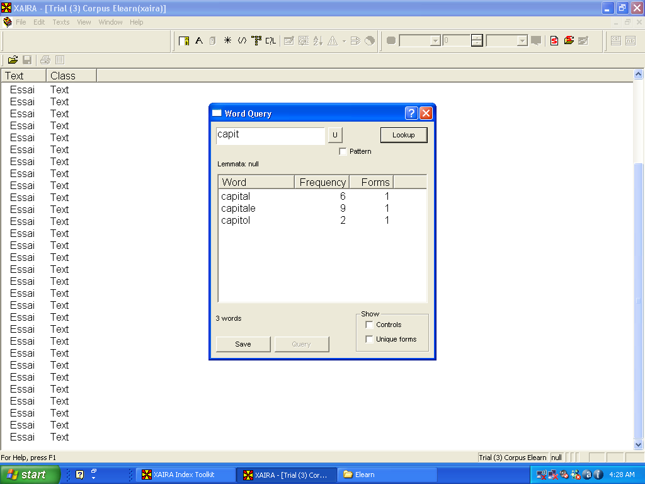

Figure 1. An instance of lexical interference from English and/or Spanish: students come up with three different ways to write ‘capital city’ in French.

When compared to native speaker corpora, initial analysis reveals that the features found in this French learner corpus have mainly to do with:
- The interference of the mother tongue (L1) in the mainly syntactical aspects of the learners’ French production such as the undifferentiated use of feminine or masculine forms;
- The interference of a very prevalent second/foreign language (L2), namely Spanish, principally seen in the lexical erroneous forms produced;
- The influence played by the language used in the course books;
- The overgeneralization of some aspects of the L2 syntax such as the exclusive use of the auxiliary ‘avoir’ to conjugate the ´passé composé’ tense.

An example of lexical interference from English, reinforced by Spanish, is shown in Figure 1 above. The word ‘capital city’ being a cognate in the three languages, it is no wonder that students are tempted to write it ‘capital’ without the final ‘e’ which is a characteristic of written French but is nonexistent when it comes to pronunciation.

An instance of syntactical confusion is shown in Figure 2 below which details some uses of the French preposition ‘en’ that learners still regard as an equivalent of the English ‘in’. To say that one lives or works in a particular city or island, ‘en’ is used in French when the correct preposition should have been ‘à’ (this rule is valid for most islands in the Caribbean). This assimilation is again reinforced by Spanish which requires the preposition ‘en’ in the same syntactical contexts.

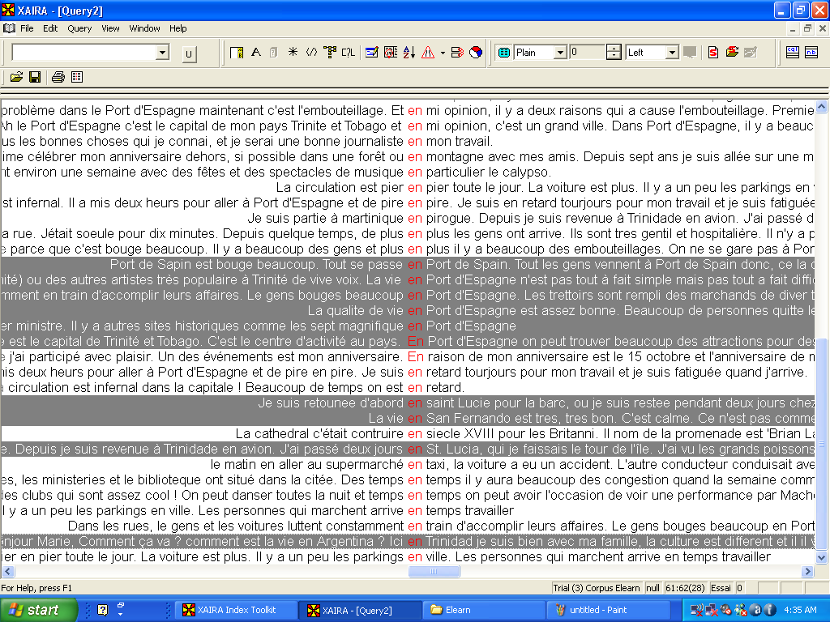

Figure 2. Use of the preposition ‘en’ to refer to the city and/or island one lives or works in when the correct form should be ‘à’.

Formulaic parroting, which is characteristic of the initial stages of foreign language acquisition, is demonstrated in Figure 3. Beginners in a foreign language will start learning by heart a series of rote utterances with which to cope in some basic interactions like greeting people and asking for directions, something very similar to the survival guides published for travellers of foreign lands that list the most common phrases and expressions. This tendency is present throughout the learning process and is an integral part of the interlanguage of students. As the student grows more proficient and feels better at ease in the FL, this parroting will diminish to be replaced by more original and personal productions. In the example given below, the expression ‘riche sur le plan du patrimoine’ which means ‘a very rich cultural heritage’ keeps popping up in the CLL students’ productions.

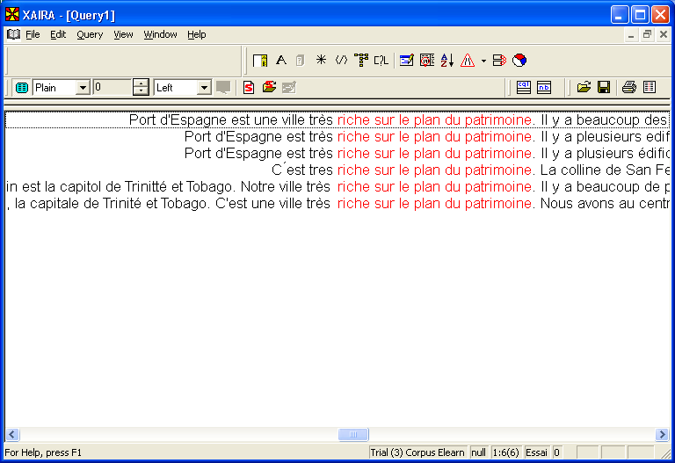

Figure 3. Influence of the course book language on the students’ productions.

Figure 4 below shows how students over generalize grammar rules in the target language disregarding the irregular cases. In this instance, the ‘ez’ ending for the polite or plural ‘you’ form of the verbs, which applies to most tenses in French – with sometimes the adjunction of another phoneme – is used for the verb ‘to be’ that is actually an exception to the rule.

BENEFITS TO THE TUTORS
Identifying and analysing such frequency problems are important in understanding the interlanguage associated with a particular learner population in their endeavour to learn a specific foreign language. Chinese learners of French certainly do not share the same interlanguage as Caribbean learners of French. Even British learners of French do not resemble the Caribbean learners of that same language. One obvious reason lies in the fact that different mother tongues lead to different interferences within the learning process.

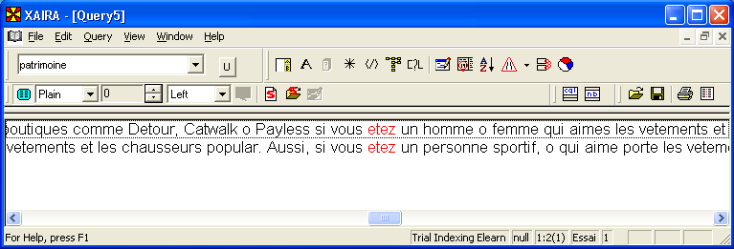

Figure 4. An instance of overgeneralization of syntactical rules in the target language.

Understanding this interlanguage can lead to improving the tutors’ pedagogical strategies used to teach the foreign language. The teaching approach can be adapted to suit the particular difficulties students encounter when learning French.

Tutors will have access to convincing evidence with which to evaluate the textbook used to teach French. Textbooks very often are – for commercial reasons mainly – far too broad in their approach of foreign language acquisition. They need to be supplemented with additional materials targeted towards the specific learner population. This Caribbean French Learner Corpus will give tutors a definite sense of the aspects of French syntax or lexicon that require additional attention for the particular community of learners given to their care. Reinforcement can then be an integral part of the pedagogical approach through the design of specially targeted exercises.

BENEFITS TO THE STUDENTS
The corpus and the analysis tools associated with it should be accessible to students as well, if possible on line or stored on CD-ROMs.

It would allow learners not to be restricted mainly to their own output but to have access to numerous students’ productions. This would represent a direct contact and a hands-on approach to the recurrent problems faced by Caribbean learners of French. It will also allow students to get a sense of the improvements achieved by students by browsing the output of students at lower or upper levels.

This tool should reinforce the students’ autonomy as they will be able to use it in their own good time, either at home or in the Self Access Facility of the Centre for Language Learning which housed a collection of self-help material to enhance the learning experience of language students.

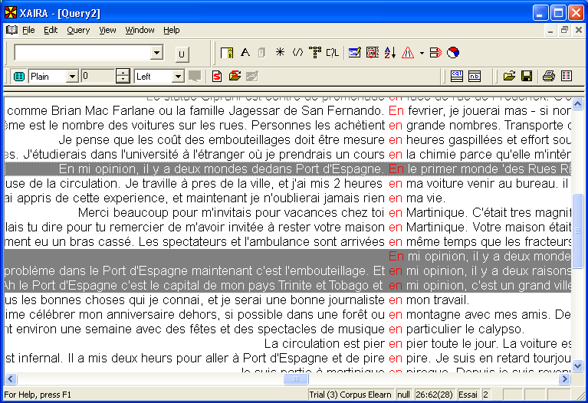

Figure 5. A clear instance of the influence of Spanish.

By being shown numerous instances of the same syntactic or lexical errors, learners should get a precious feedback and be able to improve their internal French Learner Grammar which is the cornerstone of the normal foreign language learning process (Hanzeli 1975).

CONCLUSION
This is definitely a work in progress. The results so far are only preliminary and analysis of the corpus is continuing. Certainly the different stages linked to the interlanguage development have just started to be examined and initial results are too few yet to be mentioned in this paper. The whole project should be completed by early 2010 and made available to students and tutors in the second semester of that academic year.

It is hoped that by the end of this research, learners and tutors alike should be benefiting from the analyses made and the interpretation given. The Caribbean French Learner Corpus will help identify the peculiarities of the CLL students’ French interlanguage that are often due to the intrusion of their L1 and/or L2 and also to developmental processes. In doing so, this corpus should help students learn French better and more efficiently.

Once made available to a wider audience, it will also disseminate useful insights related to foreign language acquisition in Trinidad and Tobago. In that respect, it hopes to contribute to the study of foreign language interlanguage.

Initial analyses and interpretation of the data confirm some initial impressions: Trinidadian learners of French differ significantly from other English-speaking learners of the language due to the distinct variety of English they use, their proximity to South America and also their particular heritage which draw on different European cultures and languages.

REFERENCES

“Cambridge Learner Corpus”, in Cambridge International Corpus, accessed 8 May 2009, from <http://ww.cambridge.org/elt/corpus/learner_corpus.htm>
“International Corpus of Learner English-ICLE”, in Centre for English Corpus Linguistics-CECL, accessed 8 May 2009, from <http://cecl.fltr.ucl.ac.be/Cecl-Projects/Icle/icle.htm>
“The Longman Learners’ Corpus”, in Longman Dictionaries, accessed 8 May 2009, from <http://ww.pearsonlongman.com/dictionaries/corpus/learners.html>
Barlow, M. 2005. “Computer-based analyses of learner language”, in Ellis, R. & Barkhuizen G. (eds.), Analysing Learner Language, Oxford University press, Oxford, pp. 335-357.
Biber, D., Conrad, S. & Reppen, R. 1998. Corpus linguistics: Investigating language structure and use, Cambridge University Press, Cambridge.
Ellis, R. & Barkhuizen G. (eds.) 2005. Analysing Learner Language, Oxford University Press, Oxford.
Granger, S. (ed.) 1998. Learner English on Computer, Longman, Harlow.
Hanzeli, V. E. 1975. “Learner´s Language: Implications of Recent Research for Foreign Language Instruction”. The Modern Language Journal, vol. 59, no. 8, pp. 426-432.
Jantunen, J. H. “International Corpus of Learner Finnish”, in Corpus Study on Language-Specific and Universal Features in Learner Language, accessed 8 May 2009, from <http://www.oulu.fi/hutk/sutvi/oppijankieli/en/ICLFI_Corpus.html>
Nelson, G. International Corpus of English, accessed 8 may 2009, from <http://www.ucl.ac.uk/english-usage/ice/>
Partington, A. 1998. Patterns and Meanings: Using Corpora for English Language Research and Teaching, John Benjamins Publishing Co., Philadelphia.
Rybak S., Ollerenshaw, J. & Hill, B. 2003. Breakthrough French 3 (2nd ed.), Palgrave Macmillan, Basingstoke, Hampshire.
Rybak, S. & Hill, B. 2003. Breakthrough French 1 (4th ed.), Palgrave Macmillan, Basingstoke, Hampshire.
Rybak, S. & Hill, B. 2003. Breakthrough French 2 (2nd ed.), Palgrave Macmillan, Basingstoke, Hampshire.
Saussure de, F. 1964. Cours de Linguistique Générale, Payot, Paris.
Sinclair, J. 1991. Corpus, Concordance, Collocation, Oxford University Press, Oxford.
Sinclair, J. 2004. How to Use Corpora in Language Teaching, John Benjamins Publishing Co., Philadelphia.

