Creating Reusable Lesson Plans for E-learning using the IMS Learning Design Specification

Diana Ragbir and Permanand Mohan

Department of Mathematics and Computer Science
The University of the West Indies, St. Augustine, Trinidad and Tobago
diana.ragbir@gmail.com, permanand.mohan@sta.uwi.edu

Abstract
This paper explains how to create reusable, interoperable lesson plans for e-learning using the IMS LD specification. Reusable lesson plans will enable instructors to share learning designs with other instructors and instructional designers and reduce the costs and time spent in designing e-learning material. We describe how to create three Learning Designs that are reusable lesson plans in the fields of information technology, language learning and science. We also discuss the methodology used to create the Learning Designs followed by an analysis of their capability for reuse and the pedagogical expressiveness of the specification. Finally, we discuss current research in improving the specification as well as increasing its adoption in learning organizations.

INTRODUCTION

Current Learning Content Management Systems (LCMS) enable teachers to post content and create courses using specific types of activities and a variety of digital content commonly referred to as learning objects. However, they do not enable the creation of reusable lesson plans. The activities, instructions and interactions that students engage in during a course is referred to as the teaching/learning process or the lesson plan. Since these LCMSs integrate the lesson plan with the content it is not possible to separate the teaching/learning process from the resources used within a course. Thus, the lesson plan cannot be shared and reused in the design of a different course. Also, this process is not interoperable among different LCMSs since no standard format for describing it is followed. In addition, LCMSs limit the pedagogical approaches that can be used in the design of a lesson plan since they provide a limited set of activities and resource types that can be used in the design of a lesson plan. Hence, a standard method is required that can describe any pedagogical approach that does not limit the lesson plan to specific activities as in an LCMS but which results in an interoperable lesson plan that can be reused amongst LCMSs (Koper 2005).

The IMS Learning Design (IMS LD) specification (IMS Global Learning Consortium Inc. 2003) has been heralded as the de facto standard for the description of instructional designs for e-learning systems. It is intended to encode the process of any learning situation in a standard way such that lesson plans are interoperable with any learning system. The ability to define any learning process in a standard way is essential to the provision of high quality learning since focus is placed on the pedagogical approaches ingrained in the design of lesson plans. Additionally, since these designs are interoperable with any learning system, they can be shared, improved and reused amongst the learning community.

REUSABLE LEARNING DESIGNS

The IMS Learning Design Specification provides a standard way to describe a lesson plan using any pedagogical approach and results in a Learning Design document that can be played in an LCMS that is compliant with the specification. LD is commonly explained as follows: a user carrying out a set of activities, using a specific environment, to achieve a specific objective. This sequence is specified in the method part of the LD. LD follows the metaphor of a theatrical play, where the method contains one or more simultaneous plays, which contains one or more sequential acts. The learning-design tag is at the top level and consists of a title, learning objectives, prerequisites, components and a method. Within a unit of learning, the learning-design tag replaces the organization tag in the Content Package manifest. Components consist of the core elements of the LD language which are the roles, activities, and environments and these are referred to by the method. The method describes the actual learning process using plays, acts, and role parts. An IMS LD template refers to the Learning Design document without reference to any learning content, thus the template simply represents the pedagogical process behind the lesson plan for which learning material must be filled in. This template can be reused for various courses by simply using the given pedagogy and filling in the specific learning material or a Learning Design document containing all learning material (a unit of learning) can be reused in its entirety.

The Learning Design template is populated with content or learning objects for the relevant course and is run as an e-learning course or used as a lesson plan in face to face classes. Several Learning Designs are created following the methodology outlined in the IMS LD specification. Firstly, a description of the lesson plan is developed in plain language. Then, this narrative is analysed and a UML activity diagram is created that shows the workflows and parallel processes that occur in the lesson plan. The UML diagram is then used to create the Learning Design document using the notation described in the IMS LD specification. The Learning Designs created are based on three different disciplines – information technology, science and language learning.

Information Technology

Figures 1(a) and 1(b) show an example of a learning design represented using the IMS LD notation. It is based on parts of the “What is greatness?” use-case created by James Dalziel in (Dalziel 2005). This use-case was chosen since its pedagogical structure can be used in a lesson to explore the definition of any topic by simply changing the content of the LD document that represents the use-case. Thus, ‘What is greatness?’ is changed to ‘What is an Object?’ in the example below.

The example shows a very simple template for a learning process that teaches students about software objects in a course on Object-Oriented Programming. An LD document is read from the method first. The method in this example consists of one play and two acts with each act specifying two role-parts. Within the first act, the first role-part, “RP-learner-1” (Figure 1(b)), contains an activity-structure, “AS-1”, which comprises two learning-activities (Figure 1(a)) and an environment. The role-part specifies which role performs which activity (who does what). The “AS-1” activity-structure presents an environment, in which the learner is asked to review some definitions of an object through resources provided. Next, the learner is asked to enter some examples of objects. The “LA-enter-examples” learning-activity has an activity-description that has an item which references the necessary resource. The LP-examples property is set for each user when examples are submitted by the learner. This activity is completed when the tutor indicates that it is complete via a set property.

The second role-part in the first act specifies a support-activity, “SA-1” for the tutor role in which the tutor monitors the examples entered by each learner and sets the “LA-enter-examples” activity to be completed (the LP-activity-2-completed property is set). The second act allows the learner and the tutor to respond to the examples. The learner is given instructions to create an object in software, collaborating offline with other learners, to which the tutor must give a response.

The learning design example allows a student to play the role of learner and the teacher to play the role of tutor. The learners are presented with the first activity in which they browse the available resources on the topic ‘Objects’. Each learner ends the activity individually, following which the second activity is presented. Learners are given instructions to submit examples of objects, meanwhile, the tutor reviews the submissions; this activity is ended by the tutor for all students. The last activity presents the learner with instructions to respond to the examples of other learners, while the tutor responds to each learner’s submission. The tutor ends this activity as well, and the run of the UOL is then completed. The learning design given in Figures 1(a) and 1(b) is a small fragment that may be used within a lesson to introduce a particular concept.

Science

Similarly, the example above can be reused for introducing topics in science such as “What is osmosis?” or “What is the law of inertia?”. The template described above can be used as is where the learning material alone changes to suit the science topic being taught. However, additional learning activities can be included to represent a more practical, ‘hands on’ experience. Thus, the template must be modified but can then be reused for such learning situations.

In addition, the example can also be modified to suit a particular purpose; for instance, the first learning activity can reference an environment which includes animated videos of the specific concept being taught. Also, the “LA-enter-examples” activity can be changed to allow learners to enter their own animation videos of a particular concept instead of text examples; in this case only the activity description would be changed. Finally, the example above can be reused without any changes to the learning design; the content for the specific science topic is simply included into the unit of learning.
Figure 1(a) Part 1 of an XML Document Representing a Learning Design
Figure 1(b) Part 2 of an XML Document Representing a Learning Design
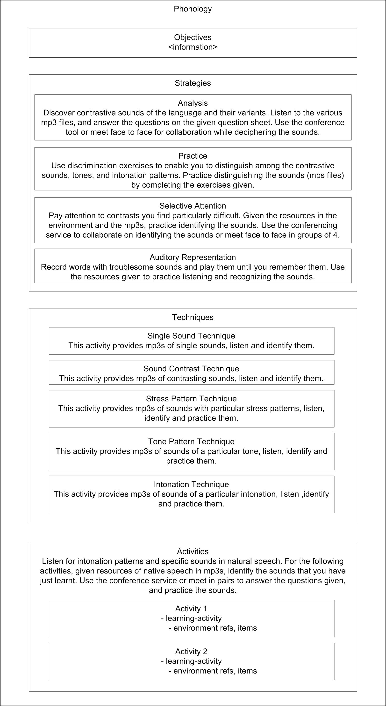

Figure 2. A lesson plan for teaching introductory phonics of the French language.

Language Learning

Now we show how to build a Learning Design for learning French, in particular a week long lesson plan for teaching or learning introductory phonics. Figure 2 above gives a representation of the lessons and its groupings for the French phonology Learning Design. This diagram is derived from the book, “Guidelines for a Language and Culture Learning Program” (Orwig 1999). It should be noted that this is not the only teaching process that can be represented using IMS LD - the lesson plan represented in Figure 2 can be modified or changed entirely.

The phonology lesson plan contains four major types of activities: objectives, strategies, techniques and activities. Strategies are broken down into analysis type and practice type activities and those that involve selective attention and auditory representation. Following these are the techniques that must be performed in this plan. There is also a section containing some supplementary activities that must be followed. All activities are eventually represented in the Learning Design document as either learning-activities or support-activities.

Using the groupings in Figure 2, activity-structures are formed as follows. The first is AS-Phonology which contains three activity-structures, AS-strategies, AS-techniques, and AS-activities. The AS-strategies component contains four more activity-structures, with each containing learning-activities (LA) and within each LA, there are items that refer to resources and environment-refs that refer to environments. The AS-techniques component contains five activity-structures also with each containing LAs. Finally, the AS-activities structure contains two learning-activities.

In this Learning Design the method would contain one play which has one act which has two role-parts. The first role-part specifies that the learner role will start from the AS-phonology activity-structure and the second role-part specifies that the tutor role will perform a support-activity throughout the lesson. The AS-phonology activity-structure leads sequentially depth first from one activity to the next until all are completed. This lesson plan can of course be made more sophisticated with the use of properties, conditions and notifications. For example, using properties to keep track of each user’s progress, the tutor can control when an activity ends, and when the whole group moves on together or individually. Notifications can also be used to notify the tutor when a student submits a question or an assignment. Conditions can further enrich the ordering of activities.

Some foreign languages are similar in many ways due to their origins. For example, Italian, Spanish, and French have a common Latin influence and can benefit from the basic structures that are taught in Latin (Morton-Finney 1941). The Learning Design example in Figure 2 was made explicitly for learning the phonology of the French language. The pedagogical approach can be reused not just by changing the resources for teaching phonics of the French language, but by changing the resources for teaching phonics of any other language that is applicable. Thus, it is possible for an excellent Learning Design created for learning some aspect of French to be replicated for learning a similar aspect of Spanish, resulting in the sharing of best practices in language learning across languages.

DISCUSSION AND FUTURE WORK

The reuse of Learning Designs can yield results in cost benefits since the cost of design is only incurred once. Learning Designs are shared and improved upon thus creating best practices in teaching. These benefits of IMS LD are achieved because the specification provides a standard way of communicating the processes of teaching and learning. Any instructional designer can use IMS LD to describe their particular teaching process and then share these designs for reuse and improvement. Reuse can refer to the reuse of the entire Learning Design, including all resources, or reuse of the Learning Design template by replacing the resources, or modification of the Learning Design document in terms of environments, activities, roles, and even the method of the Learning Design.

The current pedagogical strategies for e-learning lean towards the socio-constructivist theory and active and collaborative learning theories. These pedagogies require the use of collaborative tools which are provided in IMS LD via learning services. Pedagogical expressiveness of the specification is how well any learning scenario can be expressed in terms of completeness, pedagogical flexibility and personalization. We have determined that the pedagogical expressiveness of the specification can be improved through increasing the types of learning services such as chat, blog, wiki, mobile networking activities and many others, that can be included in a lesson plan (Ragbir & Mohan 2005; Ragbir & Mohan 2006). This is addressed by research being done by the first author to develop a framework for the addition of new services to the IMS LD specification in addition to the conference, email, monitor, and indexing services which already exists. By allowing more learning situations to be expressed in LD using such services, the pedagogical expressiveness of the specification is increased.

Additionally, an editor that enables teachers to create Learning Designs that are compliant with the specification is also being developed (Ragbir & Mohan 2009). The specification is complex and educators are not equipped to utilize the technical notation of the specification for the creation of lesson plans (Westera et al. 2005). Consequently, the adoption of the specification is restricted to those who have technical expertise and to those institutions that can afford such specialized expertise. Thus, the creation of a high-level editor that enables non-IMS LD experts could be useful to teachers in creating lesson plans that are compliant with the specification.

CONCLUSION

The IMS Learning Design specification describes a notation that can be used to encode any pedagogical process. This process is described in terms of activities that are performed by specific persons using a specific environment. We have shown how to use this specification to create three Learning Designs in various disciplines and have explored the need for improvement of the specification via services and a high-level tool.

REFERENCES

Dalziel, J. From re-usable e-learning content to re-usable learning designs: Lessons from LAMS. [online]. 2005. [cited March 2009]. Available from:
<http://wiki.lamsfoundation.org/download/attachments/9469955/dalziel_r eusable.pdf>

IMS Global Learning Consortium Inc. (IMS GLC). 2001-2008d. IMS Global Learning Consortium: IMS Learning Design Specification - Information Model, Best Practice and Implementation Guide, Binding document, Schemas. [online]. 2003. [cited October 2005]. Available from: <http://www.imsglobal.org/learningdesign/index.cfm>.

Koper, R. 2005. An Introduction to Learning Design. In Learning Design: A Handbook on Modelling and Delivering Networked Education and Training, edited by R. Koper and C. Tattersall, 3-20. The Netherlands: Springer.

Morton-Finney, P. 1941. Latin, a Basis for French and Spanish Study as Evidenced by Teachers' Mark. The Modern Language Journal, 25 (11), 873-880.

Orwig, C. J. 1999. Guidelines for a Language and Culture Learning Program. Retrieved May 15, 2007, from:
http://www.sil.org/lingualinks/LANGUAGELEARNING/OtherResources/GudlnsFrALnggAndCltrLrnngPrgrm/contents.htm

Ragbir, D. & Mohan, P. 2005. Extending the Learning Design Specification with Services. In G. Richards (Ed.), Proceedings of World Conference on E-Learning in Corporate, Government, Healthcare, and Higher Education 2005 (pp. 2784-2792). Chesapeake, VA: AACE.

Ragbir, D. & Mohan, P. 2006. Chapter 6: The Potential of IMS Learning Design in eLearning. In Handbook of research on instructional systems and technology, Terry T. Kidd, Holim Song (Eds.).

Ragbir, D. & Mohan, P. 2009. Design of an IMS LD Editor using non-IMS LD concepts. In Proc. Ninth IEEE International Conference on Advanced Learning Technologies (ICALT’09)15-17 July,2009. (To Appear). Riga, Latvia.

Westera, W., F. Brouns, K. Pannekeet, J. Janssen, and J. Manderveld. 2005. Achieving E-learning with IMS Learning Design - Workflow Implications at the Open University of the Netherlands. Educational Technology & Society 8(3): 216-225. [online]. 2005. [cited June 2008]. Available from: <http://dspace.ou.nl/handle/1820/443>.

The learning or education community refers to organizations and persons involved in teaching, developing learning materials and supporting learning in any way, including schools, training institutions, research institutions, educators, learning technologists and many others.

