E-learning at the Arthur Lok Jack Graduate School of Business - A Survey of Faculty

Abstract
This paper seeks to examine the views and perceptions of the faculty at the Arthur Lok Jack Graduate School of Business on moving into an environment of blended learning. A survey was administered to a cross-section of faculty members to gain their perceptions on the schools’ move towards blended learning. The results of which would inform the strategic direction and choices of the school in its trust towards blended learning. The results indicated that while faculty generally views blended learning positively, there are some areas of concern that must be addressed to ensure successful implementation.

INTRODUCTION

One area that has experienced phenomenal changes as a result of the use of Internet technology is the area of education. The concept e-learning is facilitating the teaching and learning experience using new channels and technologies. The education lexicon has grown in this context to include terms as ‘virtual classroom’, ‘web-based learning’, ‘online learning’, distance learning and ‘blended learning’, among others. While they all refer to the same concept, many overlaps can be seen within these terms. Urdan and Weggen (2000), for instance, found that online learning constitutes just one part of e-learning; and further define it as learning processes that take place via the Internet and in blended classroom contexts. They specified that e-learning covers a wide spectrum of applications and processes, including virtual classrooms and digital collaboration.

However it is defined, e-learning has grown in popularity in a very short space of time. Spender (2001) asserts that e-learning is the next generation of learning in light of its flexibility. In a national survey of chief academic officers, Allen & Seaman (2004, quoted in Bonk and Kim 2006, p. 23) reported that 52.6% viewed online learning as critical to their institution’s overall long-term strategy. That same survey reported that a majority of all American colleges and universities were offering fully online courses enrolling approximately 2 million students. In public sector institutions especially where increasing student access to education is an important part of their missions, the percentage offering online courses was as high as 90%.
In this region the University of the West Indies has been at the forefront in pioneering the use of e-learning in the English speaking Caribbean. Some the affiliated institution of the University of the West Indies like the Open Campus offers first degree programmes using blended learning while other like the Arthur Lok Jack School of Business have launched its e-learning platform but is now is the process of contemplating the use of blended learning.
It is within this context that the aim of this paper is to examine the perception of the members of the faculty of the Arthur Lok Jack Graduate School of Business on the use of blended learning in the academic programmes.
The objectives are as follows:
- To determine to what extent the present e-learning system is being used
- To gain an insight into how faculty feels about moving their courses to a blended learning environment
- To foresee hurdles or limitations the school is likely to encounter in moving towards blended learning

What is Blended Learning
Garrison and Vaughn (2008) describes the basic principle of blended learning as a situation where face-to-face oral communication and the online written communication are optimally integrated such that the strengths of each are blended into a unique learning experience congruent with the context and intended educational purpose.

For the purposes of this paper, blended learning is seen as the integration of a variety of technological delivery methods with the traditional face-to-face classroom activities thus facilitating the use of asynchronous methods in the process of teaching and learning.

INSTITUTIONAL BACKGROUND

The Arthur Lok Jack Graduate School of Business (formerly the UWI-Institute of Business) was established in 1989 as a joint venture between the University of the West Indies and the private sector of Trinidad and Tobago to provide postgraduate education in business and management. The school is recognized as being foremost in the provision of business and management education, training and consultancy services in Trinidad and Tobago and the wider Caribbean region. The faculty comprise largely of adjunct staff from industry and government.
The move towards e-learning has been slow since high level of face-to-face interaction is seen as a major strength in attracting students to the institute. However, the growth of the student body over the past two years and the number of days students must attend classes per week, has put a strain on the physical capacity in terms of classroom space. To help alleviate this problem management has sort to hasten the move towards the use of blended learning. To this end, the perception of faculty is a critical factor that affects the process. Jarlan (2004) asserts that “buy-in” from teachers is essential. Put simply, even though there is a recognized need for increased access, e-learning technologies cannot be used effectively without the full support of those who will use them (e.g., faculty and staff). For example, teachers must transition away from traditional methods of teaching, towards a more constructivist pedagogy that will enable students to derive full benefit from e-learning (O’Donnell, 1991).

METHODOLOGY

A questionnaire was administered to members of faculty during the period December 2008 and February 2009. The questionnaire had a preamble and three main sections. The preamble outlined the schools’ move towards using online technology in programme delivery and gave a brief description of blended learning. The first section captured data on number of years the respondent had been a member of faculty, the subject area group to which the faculty member belong and whether they presently use Lok Jack e-learning.

In the second section, faculty rated a series of statement on blended learning on a five point Likert scale, with 1 being strongly agree and 5 being strongly agree. In the final section, respondents were given the option to express their views on perceived advantages and general concerns they had on the move towards blended learning. A total of 70 questionnaires were given out to a random selection of faculty members and a total 32 usable response was received.

FINDINGS AND ANALYSIS

The graphs below show the breakdown of the responses in terms of Subject Area Group and years as a member of faculty.

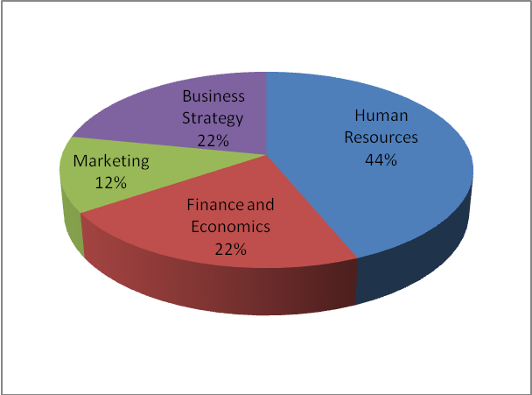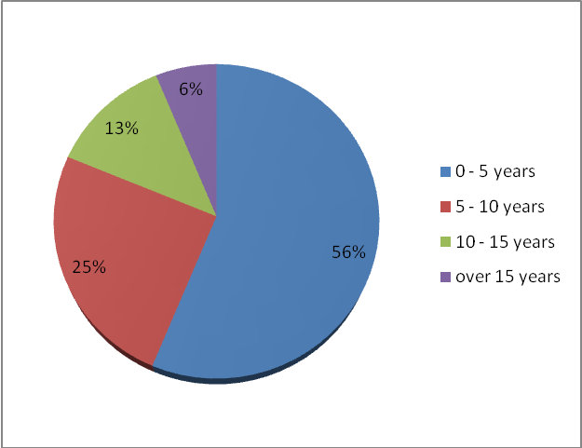
Figure 1 – Respondents Subject Area Group
Figure 2 – Years as Faculty Member

As can be seen from Figure 1 above, 44% of the responses were from Human Resources, while Finance and Economic and Business Strategy had 22% each and Marketing 12%. In terms of years of service, Figure 2 shows that just over 75% of the respondents had less than 10 years service with the institution.

Table 1 – Utilization of Lok Jack e-learning

 |  |  | Yes | No
Do you use Lok Jack e-learning |  |  | 33% | 67%
Previous experience in online teaching |  |  | 60% | 40%

As can be seen from Table 1, only 33% of the staff uses the present e-learning system in the delivery of their course. The use of the e-learning system is mostly limited to posting of readings and lecture material. There were very few instances of online assignment submission and online discussion forums. It was notable however that 60% of the faculty had previous experience in online teaching, which suggests that the school need to do more to encourage faculty to use the online mode.

Table 2 – Faculty Perception on Blended Learning

Statement on Blended Learning | Mean | Std Dev.
Enriches the learning experience of our students | 4.25 | 0.70
Saves time and effort for both teacher and students | 3.53 | 0.87
Reduce teamwork and collaboration between students | 2.91 | 0.98
Causes loss of consistency in learning due to fragmentation | 2.41 | 0.78
Makes it easy to monitor teaching and learning processes | 3.47 | 0.71
Makes it difficult to monitor the evaluation processes | 2.44 | 0.63
Would result in a decline in the learners’ achievement | 2.16 | 0.61
Provides for cost efficiency in teaching and learning | 3.91 | 0.63
There would be a need to standardize the course content | 3.75 | 0.81
Faculty would require training in the course management software | 4.53 | 0.59
Lecturers would need to have well prepared online materials | 4.66 | 0.52
The school would be required to improve its present technological infrastructure | 4.16 | 0.84
Would require varied teaching strategies be employed | 4.31 | 0.49
Faculty would require training in course design and delivery for this new mode | 4.38 | 0.59
The move towards blended learning would negatively affect the schools ability to attract students | 1.88 | 0.66
Eventually all courses should integrate the use of blended learning | 3.97 | 0.79
It would be difficult to adapt my course for the blended learning environment | 1.91 | 0.68

Table 2 given the results of how faculty perceives blended learning based on a series of 17 statements which they were asked to rate on a 5 point scale. Overall the faculty held a positive view of blended learning. The relatively small standard deviation indicates that hold fairly similar views. The results indicate that faculty saw blended learning as enriching the learning experience and saving time and money. However, they tend to see it as reducing teamwork and collaboration between students and were also unsure as to whether blended learning would cause loss in learning consistence due to fragmentation. While they were mostly convinced that it would be easy to monitor teaching and learning processes they were unsure as to how difficult it would be to monitor the evaluation and assessment processes.
Research suggests however the online environment does support teamwork development and collaboration (Harasim 1995, Kemp 2006). Also, Aycock, Garnham, & Kaleta (2002) emphasize that faculty development stress the integration of “online material with face to face interaction so they aren’t two courses.” In terms of assessment, the question of monitoring has to do with ensuring that the student themselves undertake the evaluation exercise. The extent of dishonesty however could be mitigates by the design of the assessment methods. There is evidence that on-line assessment, unless carefully planned, can encourage students to focus on lower level cognitive skills. The educational effectiveness of on-line assessment that concentrates primarily or exclusively on true/false or multiple choice responses, for example, is highly questionable in a higher education environment (Delvin 2002). In a study of pedagogical practices, Bonk (2001) found that only 23–45 percent of online instructors surveyed actually used online activities related to critical and creative thinking, hands-on performances, interactive labs, data analysis, and scientific simulations although 40 percent of the participants said those activities were highly important in online learning environments.

There is strong indication that the faculty believes they need to be trained in the technical aspects of the course management software and in course design and delivery. The need for training is seen as most important for the success of blended learning (Ranjan 2007). Mason (2001) recommends a comprehensive staff training initiatives that allows those involved to become proficient in the technical and educational aspects of e-learning. Training initiatives must integrate “learning about educational design” with hands-on “learning how to use the technological devices and tools” to teach. Teachers therefore must be encouraged to become active participants in the design and implementation of e-learning processes, instead of having it imposed upon them.

Faculty also strongly believes that lecturers would need to have well prepared online material, which would need to be standardize and that a variety of teaching method must be employed. Kim and Bonk (2006) indicates that planning and moderating skills are perhaps more important than actual “teaching” or lecturing skills in online courses. They contend that “online instructor during the next few years would be how to moderate or facilitate learning and how to develop or plan for high-quality online courses. Being a subject-matter expert was the next most important skill.” This is critical point for the Lok Jack School of business since the choice of faculty is largely determined by subject expertise and industry experience.

Faculty also saw the need to have the school improve its technological infrastructure to properly support blended learning. It was encouraging to note that faculty did not perceive that the move towards blended learning would affect the schools’ ability to attract students and that it would not be difficult to adapt their courses for the blended learning environment. These latter results can be interpreted as a positive sign of ‘buy-in’ from faculty in moving towards blended learning.

CONCLUSIONS

These results of this survey provide useful insights in shaping the process as the Lok Jack School of Business move forward in enabling blended learning. The results points to critical success factor such as the need for training and a dependable IT infrastructure, as well as allow for the identification of perceptual gaps. These perceptual gaps exist where faculty perception differs from the pedagogical expectation of the institution in using blended learning, based on existing research and best practice. This was noted in the faculty perception of online delivery with regards to teamwork and collaboration, integration and assessment. It was significant however that faculty saw underscored the need for training and development as these are critical vehicles in gaining alignment in the perceptual gaps and building confidence. The training and development can serve as a catalyst in involving faculty in the most important stage of course design and planning.

REFERENCES

Allen, E.I & Seaman, J. (2005). Growing by Degrees: Online Education in the United States. Needham, Mass.: The Sloan Consortium. Quotes in Bonk C. J. & Kim, K. (2003). The Future of Online Teaching and Learning in Higher Education: The Survey Says. Educause Quarterly November 2006 pp.23

Aycock, A., Garnham, C., & Kaleta, R. (2002). Lessons Learned From the Hybrid Course Project. [Internet] Teaching Scholars Forum, 8(6). Available from: <http://www.uwsa.edu/ttt/articles/garnham2.htm> [Accessed 15 May 2009]

Bonk, C.J. (2001). Online Teaching in an Online World Bloomington, Ind.: CourseShare,

Bonk C. J. & Kim, K. (2003). The Future of Online Teaching and Learning in Higher Education: The Survey Says. Educause Quarterly November 2006 pp.22 – 30

Devilin, M. (2002). Online assessment [Internet], Centre for the Study of Higher Education. Australian Universities Teaching Committee. Available from: <http://www.cshe.unimelb.edu.au/assessinglearning/docs/Online.pdf>. [Accessed 24, May 2009.]

Garrison, R & Vaughan, N. (2008). Blended Learning in Higher Education. Jossey-Bass. Quoted in:
Starenko M.(2008). Reflections on Blended Learning: Rethinking the Classroom. Rochester Institute of Technology, pp 3.

Harasim, L. M. (1989). Online Education: An Environment for Collaboration and Intellectual Amplification. Quoted in L. M. Harasim (Ed.), Online Education: Perspectives on a New Environment, New York: Praeger, pp. 39-64.

Jamlan, M. (2004). Faculty Opinion Towards Introducing e-learning at the University of Bahrain. [Internet] The International Review of Research in Open and Distance Learning, Vol 5, No 2. Available from http://www.irrodl.org/index.php/irrodl/article/view/185/267 [Assessed 20 November 2008]

Kemp, L. J. (2006). Learning about Teamwork in an Online Study Environment. MERLOT Journal of Online Learning and Teaching. Vol 2. No. 1, pp 30 – 41.

Mason, M. (2001). Globalising Education: Trend and Applications. London: Routledge

O’Donnell, J. (1991). Teacher Perception of Their e-learning Needs to Integrate e-learning into Classroom Instruction. Unpublished doctoral dissertation, University of Southern California at Los Angeles. Quoted in: Jamlan M. (2004). Towards Introducing e-learning at the University of Bahrain.The International Review of Research in Open and Distance Learning, Vol 5, No 2.

Ragan, L. (2007). Best Practices in Online Teaching - Pulling It All Together - Teaching
Blended Learning Courses. [Internet]. Connexions Modules m15048. Available from: http://cnx.org/content/m15048/1.2/ [Accessed 24 May 2009]
Spender, D. (2001). e-Learning: are Universities Prepared? In: Online Learning in a Borderless Market. Conference proceedings at a conference held at Griffiths University Gold Coast Campus. Canberra: Department of Education, Training and Youth Affairs, pp 59 – 63
Urdan, T. & Weggen,C. (2000).Corporate e-learning Exploring. A New Frontier. Computer News, 53(11), pp 35 – 36.

