E-Learning for Renewable Green Energy Sources
Abstract:
E-learning programs have become increasingly popular over the last few years for professionals, who need to update their knowledge and skills through internet and multimedia. This paper gives information in picture-text, model block set format and also in virtual simulating modes of renewable energy sources and to recreate different learning scenarios. The block set model representations of solar array, fuel cell and wind turbine by means Matlab/Simulink have been developed in the proposed paper.
An interactive e-learning Web site is proposed, where interactive online materials are posted for both students and instructors including lecture notes, simulation problems, examples and exercises and textbook presentations to help students better understand the system behavior under certain parameters variations. The proposed system provides the learner with information about the most important functions and operational problems of each renewable source. System performance waveforms are plotted with flexibility to allow the students to change different parameters and observe the system response in an interactive manner. The e-learning site is focusing also on closed loop response and dynamic modeling, which will enhance the performance of renewable energy systems.
Key-Words: E-learning, modeling and simulation, renewable generation, matlab/simulink, GUI.

1. Introduction

Climate change, green house gases, high oil price, limited world oil reserves are driving increasing search for new alternative and green energy resources. Therefore, nowadays all energy companies use plenty of the advanced technologies such as wind, solar and hydrogen. As those technologies change quickly, and technicians as well as working engineers do not always have enough time to attend new intensive or short courses in order to improve their knowledge and keep up to date with innovative concepts. E-learning through the internet seems the only effective and feasible solution and offers flexible learning opportunities and interactive services for the visitors to remain close to new products and processes [1- 4].

The next section discusses the requirements of E-Learning in interactive renewable energy education. In Section III, a general overview of the interactive Simulink/Sim-Power modules has been presented and the detailed components of each renewable type are modelled. Section IV presents some simulation of renewable generation under different weather and operation conditions. Future plans and final conclusions are summarized in Section V.

2. REQUIREMENTS FOR E-LEARNING SOLUTION

E-learning support system of renewable energy should meet the following requirements:
- It should be developed to allow students to acquire a possibly deep insight into the complex and dynamic interactions of system parameters.
- A high degree of interactivity should be provided and the students should have the possibility to study the causal relation between different states of the system under study.
- It should be accessible, independent of time and place.
- Lecture material based on the assigned “Renewable Energy” textbook. Moreover, several models of PV, Wind Turbines and fuel cells are posted with their simulation under different operating conditions. Students should be motivated to study and analyze these systems in more detail, so as to become skilled in designing and component layout of such systems. Thereby, the interactive applets show real time simulations for several basic topologies with the flexibility to change the input system parameters and observe the real output waveforms correspondingly[5].

3. IMPLEMENTATION OF E-LEARNING ON RENEWABLE ENERGY

Two main simultaneous processes are cooperated together to develop the e-learning applets: the Matlab modeling and the instructional design process.

a. Matlab Modeling:
Matlab modeling (M-Model) constructed from system preprocessed data that contains reduced equations with their labeling and other metadata are capable of mapping the concept to a real-world SimPower environment. The different models are coordinated together and assembled to form the studied system.

b. Instructional Design:
Instructional Design illustrates how to better present the concepts, convey the objectives of the course in a pedagogical way and appropriate it to suit the targeted audience. Interactive tutorials are accompanied with the simulation engines to support both instructor lead and self paced learning. The GUI is presented in a more informative way and is easy to use with more user-friendly buttons and graphical panels.

Next, the utilization of user-friendly and powerful computer-aided simulation software tools can help students get acquainted with the dynamic behavior of renewable energy sources and verify the correctness of their parameter design.

3. 1 Modeling of Wind Turbine/generator:

In order to study the dynamic behavior of wind generation units, their basic components have been modeled in seven block sets as shown in Fig.(1)

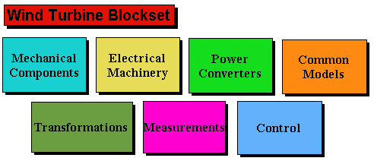

Fig. (1) Basic Block sets for wind turbine simulation and control

Variable speed operation of wind turbines is obtained by injecting a variable voltage into the rotor of double fed induction generator DFIG at slip frequency. The injected voltage is controlled to obtain the specified speed of the DFIG. The DFIG was modeled together with the different loads and reactive power compensator using Matlab/Simulink Sim-Power environment as shown in Fig. (2).

The fundamental issue for wind energy education is the ability of the students to change the wind speed and then observe the different wave forms displayed on the simulated scopes in lower part of Fig. (2) as well as through stored output data in the work space files[6].

3.2 Modeling of PV solar array:

A PV array scheme supply power to permanent magnet DC motor driving water pump in remote area is introduced. Output voltage of the PV array depends on the cell operating temperature and solar radiation. For e-learning the students can change the array voltage by selecting the number of cells in series while the load power matching is obtained by defining the number of cells in parallel, Fig. (3).

.

Fig.(2) Simulink model of isolated system with wind energy generation.

Fig.(3) Simulink model of PV array with input and output parameters.

The Simulink model consists of the PV array and the R-L filter, a fixed storage capacitor, 4-quadrant PWM converter and PMDC motor. In order to study the effect of operating conditions, the students frequently change the cell temperature and solar radiation in different time intervals. The variation in the generated voltage is then recorded [7].

3.3 Modeling of PEM Fuel Cell:

Fuel cells are electrochemical devices that convert the chemical energy of a reaction directly into electrical energy and hot water. The basic block sets of a fuel cell consist of an electrolyte layer in contact with a porous anode and cathode on either side. In a typical fuel cell, gaseous fuels (i.e. hydrogen, or hydrogen-containing fuels) are fed continuously to the anode compartment and at the same time an oxidant (oxygen from air) is fed continuously to the cathode compartment.
In order to simulate the PEM fuel cell stack, the mathematical model of the constituent subsystems must be utilized. Thereby, the activation, concentration polarization effect of the anode and cathode are taken into consideration,Fig.(4). The student can change hydrogen or oxygen flow rate, pressure and temperature of the stack and record the operation performance of the generated current, voltage, and power [8].
Fig.(4) Simulink PEM Fuel Cell model
3.4 Renewable Energy Interfacing and Control:

Typically, students should be able to change the duty cycle of interfacing power electronic devices to verify the required operating equations [9]. To avoid any oscillation or instability of the studied system, the students should test different control concepts to enhance system performance. Digital and intelligent FLC controllers are used to attain both open loop and close loop system control objectives, Fig.(5) . The controllers provide the switching signals to the power electronics converters [9].

Fig. (5) Fuzzy logic controller for PEM fuel cell stack

4. SIMULATION RESULTS:

The students can perform real time assessment of renewable resources by varying the times and amplitude of applied wind speed, solar isolation or load excursion and display system voltage, current at different buses and electric motor speed. A comparison between the performance of stack current, voltage and power for a step load changes is carried out. The simulation results indicate that when there is a sudden variation in the desired load power, the PEM fuel cell output current and voltage exhibit a good and faster response in case of using the FLC compared to the case of using the PI controller.

A hybrid efficient energy system consisting of wind, photovoltaic and fuel cells as integrated sources could be integrated and simulated by the students to ensure the continuity of the supply. Thereby, the interfacing converters used to connect electrical generators to the common DC interface-bus, where all the generated energy is first collected in a DC form. Then an inverter converts the DC to AC power at a second common AC bus interfaced to electric Utility grid. These converters and their controllers ensure maximum power conditions and dynamic matching between load and generation.

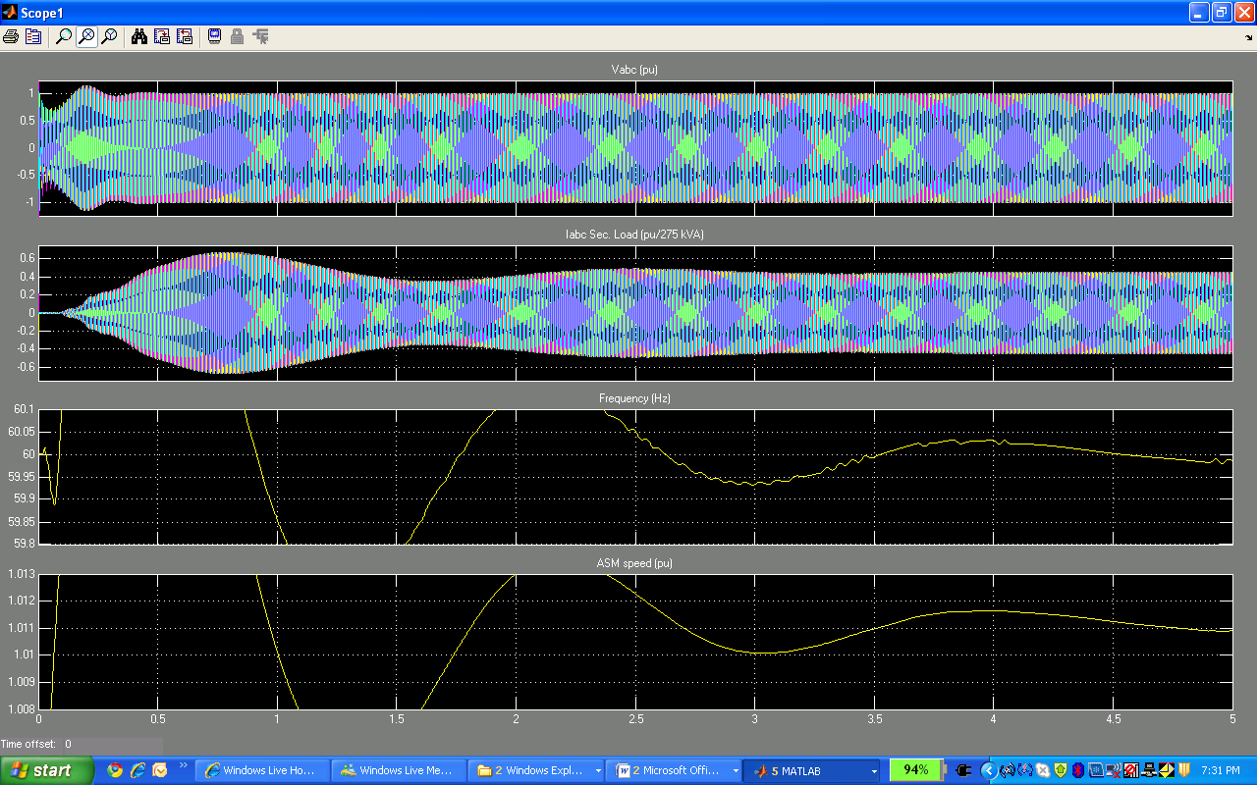

Fig. (6) DFIG output voltage response of wind turbine
Fig. (7) Output current and power of the PV array

Fig. (8) Voltage response of PEM fuel cell at step change in the desired load power

CONCLUSIONS

The rapid development of ICT technologies caused utilization of internet based e-learning educational materials for both learning and teaching purposes. This paper gives an overview of the present development for e-learning materials in field of renewable energy and displays some models to simulate such clean resources. The gained knowledge during renewable energy study has been utilized to allow the student to analyze different renewable energy configurations through development of the e-learning modules. Due to limited space for result publication the wind, solar and fuel cell are selected in the presented paper.

The proposed e-learning platform for renewable energy contains three major parts: The first part deals with the requirements of the e-learning requirements; the second part utilizes the available in internet simulation packages to model the renewable generating units in block sets. The third part displays the simulation results which could be carried out by the students under different operation conditions. Dynamic controllers were tuned to ensure a constant common DC/AC bus voltage stabilization, maximum power tracking and enhanced power quality.

E-learning enables location independent education and boasts the advantages of flexibility, friendly user interface, provision for distance response analysis and removal of laboratory time and space constraints.

6. REFERENCES

[1] Petty, I.: Vision 2020 - Education in the next Millennium. In: Hagström, A. (Ed.), Engineering Education: Rediscovering the Centre (Proc. SEFI Annual Conf., Winterthur and Zürich, 1999) pp. 27-35.

[2] R.S. Friedman, F.P. Deek, "Innovation and education in the digital age: reconciling the roles of pedagogy, technology, and the business
Of learning," IEEE Transactions on Engineering Management, Vol. 50, No. 4, Nov. 2003, pp. 403-412.

[3] M.M. Albu, K.E. Holbert, G.T. Heydt, S.D. Grigorescu, V. Trusca, "Embedding remote experimentation in power engineering education," IEEE Transactions on Power Systems, Vol. 19, No. 1, Feb. 2004, pp. 139-143.

[4] J. Hamar, H. Funato, S. Ogasawara, O. Dranga, C.K. Tse, "Multimedia based e-learning tools for dynamic modeling of DC-DC converters," Conference Record of the 2005 IEEE International Conference on Industrial Technology, 14-17 Dec. 2005, pp. 17-22.

[5] S. Wang, Y. Liu, Y. Chen, J. Su, W. Liaw, “ Web-based software programmable e-learning platform for power electronics courses”, 38 th ASEE/IEEE Frontiers in Education conference, NY, 22-25 Oct. 2008.

[6] G. Slootweg, S. De Haan, H. Polinder and W. Kling, “ General Model for representing variable speed wind turbines in power system dynamic simulations”, IEEE Transaction on Power Systems, Vol. 18, No. 1, pp. 144-151, February 2003.

[7] I. Altas, A. Sharaf, “A photovoltaic array simulation model for Matlab-Simulihk GUI Environment”, International conference on clean Electrical power, ICCEP’07, Capri, Italy, 21-23 May 2007.

[8] A. Nafeh, E. Sweelem, F. Fahmy, M. El-Sayed, "Modellig and Control of PEM Fuel Cell System in Transportation”, Scientific Bulletin of the Faculty of Engineering, Ain shams University, Part II, Electrical Engineering, Vol. 40, No. 4, Dec. 2005, pp. 807-821, Cairo, Egypt.
[9] A. Novouzi, A. Sharaf, “Two control schemes to enhance the dynamic performance of the STATCOM and SSSC”, IEEE Trans on Power Delivery, Vol. 20, no.1,pp 435-442, Jan 2005.

