Using myElearning (Moodle) as the Perfect Project Management Tool
Wayne Goodridge
The University of the West Indies
St. Augustine Campus
Trinidad and Tobago, West Indies
wayne.goodridge@sta.uwi.edu
Abstract
The negative perception continues - computer science students graduating from the UWI are unable to function adequately in information technology and software development environments. Is adding new relevant courses helping? Will more selective entry requirements make a difference? Or is it that we need to look at our teaching and learning strategies closer. This paper presents a teaching and learning strategy that is currently being used to deliver the third year software engineering computer science course in the Department of Mathematics and Computer Science at the University of the West Indies’ St. Augustine Campus. This strategy involves the implementation of Situated Learning concepts via the use of the myeLearning (Moodle) learning management system. Particular emphasis is made to how the tool can be used to assist the project management effort that is required to manage student projects.
Introduction
In the last ten years there has been growing negative perception that computer science students graduating from the University of the West Indies (UWI), St. Augustine Campus, are unable to function adequately in information technology and software development environments. These developments have triggered the need to address the teaching and learning environment of computer science students at UWI.
The “BIG” debate continues – the “old boys” want most courses to remain at 25% course work and 75% exam, and the “new boys on the block” want a higher percentage of course work to account for the final grade. So what’s the solution? Let’s step back and look at the negative stigma - unable to function adequately in information technology and software development environments. The only way to address this stigma is to create learning outcomes to ensure that our students experience information technology and software development environments. These learning outcomes mean new teaching strategies. Classes must have more practical activities and students should be given relevant projects that focus on the process of development and not the product thereof (Oliver, Herrington & Omari 1999).
The “BIG” debate continues – the “old boys” think that projects do not mean anything because students copy from past students projects and get other external help and therefore the Department cannot seriously use the mark from projects to measure whether or not a student is good enough to pass. On the other hand, the “new boys on the block” believe that projects should be one of the key teaching and learning tools to assess the students for achievement and development. So what is the compromise?
In 2006, UWI successfully adopted the Moodle (Moodle.org 2008) learning management system (LMS). UWI called this system myElearning. In the paper, “The Best Thing Created Since Sliced Bread…” (Wood-Jackson, Mahabir & John 2008), it was shown that a number of lecturers and students welcomed the change to myeLearning. This paper will show how myeLearning can be used to introduce teaching and learning strategies such as “Situated Learning” (Lueddeke 1999) to addresses the problem of making computer science students more relevant to the commercial world.
Situated Learning
Situated Learning is, “a social, dialogical process in which communities of practitioners socially negotiate the meaning of phenomena” (Oliver, Herrington & Omari 1999). Situated Learning focuses not only on the teaching of concepts but also how the learners apply and reflect on those concepts beyond the classroom. In addition, this constructivist learning philosophy recognizes that the social interaction among learners helps to promote critical thinking and reflection on the content. Hence this social interaction is critical to the learning process.
There are nine non-sequential elements of a situated learning framework that are recommended to lecturers that use this methodology for delivery (Wilson 2002):
- Provide authentic contexts that reflect the way the knowledge will be used in real life
- Provide authentic activities
- Provide access to expert performances and the modeling of processes
- Provide multiple roles and perspectives
- Support collaborative construction of knowledge
- Promote reflections and enable abstractions to be formed
- Promote articulation to enable tacit knowledge to be made explicit
- Provide coaching and scaffolding by the teacher at critical times
- Provide for authentic assessment of learning within the tasks
Some people might think that for the computer science department at UWI to follow the nine steps outlined above would require a paradigm shift in thinking. However, this paper will show how the third year Software Engineering course has used myeLearning to bring a real world project, students, the lecturer and professionals in the field together in cyberspace.
Software Engineering
Let us start by looking at a few of the learning outcomes for the third year software engineering course outline offered by the Department of Mathematics and Computer Science at UWI:
- Identify the benefits and difficulties of performing software engineering in a group.
- Analyze the requirements for a software system to produce a software design.
- Evaluate the software risks of a system,
- Demonstrate how reliability, reusability, verification and validation play a vital role for any software engineering effort.
- Apply object-oriented concepts to the software engineering process.
- Develop problem definition, requirements and specification statements.
- Develop a final design document.
It is obvious that the teaching strategies used to achieve the above learning outcomes should not be limited to chalk and talk or even the use of myeLearning to deliver raw material content. In fact, providing students with information does not guarantee learning. What is necessary to achieve the above learning outcomes are levels of learner engagement that are often outside the course materials. The key questions therefore are: (1) what activities can be used to engage students; and (2) what tools can we use to monitor these activities.
The Perfect Project Management Tool
Project Management is the business process of creating a unique product, service or result. The Project Management lifecycle (Hoffer, George & Valacich 2007) consists of five phases: Project Initiation, Project Planning, Project Execution, Project Monitoring and Control and Project Closeout. We often omit the phases of Project Planning and Project Monitoring and Control when we give students projects. To prevent this from happening, Blended Learning was used. This involves combinations of many different teaching strategies and learning environments with the goal of providing students with an optimal learning environment. So what is the optimal learning environment for the delivery of software engineering to meet the mentioned learning outcomes? The blended learning environment used:
- Wikis (a collection of Web pages designed to enable anyone with access to contribute or modify content, using a simplified markup language) for group discussions of software engineering questions. These questions required research by team members.
- myElearning individual journals that recorded week by week activities of project events
- Extensive online notes to assist students with the content
With Situated Learning in mind, the following assessment strategies were used:
- Group project given with groups containing no more than 4 students. The project was given at the start of the term. Students were given four deliverables to submit at different times in the semester. The four deliverables were: Project Plan, Requirements Analysis, Design and Implementation (Product).
- Quality of answers to questions was assessed.
- Mid-term written exam – short answer and essay questions.
- Assessment of project plan by lecturer and professional Project Manager
- Continuous assessment of revised project plans by lecturer
- End of term exam - – short answer and essay questions.
The project given was based on a real world problem, presented in the form of a case study, with a fictitious company name. Students were not necessarily familiar with how to develop a project plan; however, a sample Project Plan of a real world project was shown to them via myElearning. Although, this sample project plan did not have all the theoretical components of a project plan, it served as an important model for the students. Therefore, as the content on how to write a project plan was presented to students, they actively engaged the material because they had a reference point.
Students were asked to submit their project plans electronically to myElearning. This gave the lecturer the opportunity to show them to a professional Project Manager who gave invaluable input and guidance. Students were not told about the involvement of someone from industry. However, the feedback given was included on the student’s rubric feedback report.
The myeLearning platform also played an important role of providing the class with the opportunity to record their individual experiences on a week by week basis in the form of an electronic journal. The students were expected to discuss issues and events of the following nature:
- Strategies, tools and techniques used in the requirements and design phases of the project
- The risk mitigation techniques used to address communication and other problems in the group
- Lack of participation by some members ('passenger' syndrome)
- Frustration expressed between team members
- Domination of the team by one or two members
The postings made by students were checked three times a week. Students wrote “deep” personal reflective statements about their experiences in developing the project plan, requirements and design documents. As a result of monitoring student journals each week the Lecturer was able to identify problems that groups were having and ad-hoc meetings were arranged with the group to address any issues. The educational benefits of journal writing were:
- Give students the opportunity to express ideas and solve problems by thinking “aloud”
- Help students to examine their relationships with other students
- Help students to reflect on personal values, goals, and ideals.
- Help students and groups to monitor their growth by reading past journals.
An example of a student journal is given in Appendix A – the names used are changed to protect the identity of the students involved. Feedback was given in a timely manner to guide students through the project planning phase. This was due to the ease of communication through myElearning. The most common type of feedback was related to software costing strategies, risk identification and strategies to manage risks. In addition, most students were not sure how to schedule the feedback loops that are involved in the development of the prototype. Surprisingly, professionals writing projects plans ask the same questions. Hence the authentic assessment of the learning aspect of Situated Learning was addressed by asking students to do this activity.
The myeLearning platform has excellent reporting tools. These tools helped the lecturer monitor student activities in terms of their viewings and postings to course material. For example, the graph in Figure 1 speaks a thousand words about student activity at a single glance.
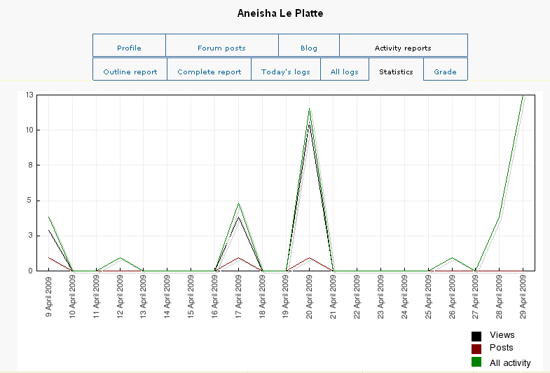
Figure 1: Activity Graph for Student
The messaging facility in myeLearning was used to email warnings to lagging students as identified by the activity reports from myElearning. In addition, because students frequently submitted their updated MS project plans to myElearning, the Lecturer was able to send feedback messages and the suggested update to the project plan to members of specific group.
Apart from the goal of producing students that can function adequately in information technology and software development environments, it is also necessary for the students to have a sound academic and research background. Wiki discussion questions were extensively used in the course to accomplish this goal. Students were told that some of these questions could be repeated in the midterm and final exams. This motivated them to participant in private group Wiki activities where only members of the group can view and post to the group Wiki. More importantly, it was a way for the lecturer to get early feedback of the notions students were formulating. This feedback was used to design future lessons. Because of the fear of a question coming in the exam students actively engaged the course material.
Conclusion
This paper examined how myeLearning can be used in a blended learning environment to assist students with gaining more experienced based learning. A specific learning and assessment environment was constructed to address the desired learning outcomes for the final year software engineering course in the Mathematics and Computer Science Department at UWI, St. Augustine. Because the bulk of the student effort is focused on the process and not the product, this serves as the perfect reason for rewarding the students a higher course work percentage mark than the written exam. The question of whether or not a project is a valid and reliable technique for measuring the achievement made by students was also adequately addressed since each student is required to record reflective statements about the project each week. Of course, this approach requires constant monitoring and feedback from lecturers in the learning process. That is, the lecturer really is performing the role of project manager. This paper illustrates that myELearning gives the lecturer the perfect tool to manage student projects.
The learning approach described in this paper helps with the negative perception that computer science graduates have by allowing our students to engage more. What they do in school is the same thing they do at work.

References
Hoffer, J.A., George, J. and Valacich, J. 2007. Modern Systems Analysis and Design, Fifth Edition, Reading, MA: Pearson/Prentice Hall Publishing Company.
Lueddeke, G. R. 1999. “Toward a constructivist framework for guiding change and innovation in higher education”. Journal of Higher Education, 70(3), 235-237.
Moodle.org. (2009). Retrieved from http://www.moodle.org/
Oliver, R., Herrington, J., & Omari, A.1999. Using flexible learning approaches to create a converged learning environment for on and off-campus learners”.
Wilson, W. 2002. Lessons in Reality: Teaching Project Management, Professionalism and Ethics to Third Year IT Students. Informing Science, InSITE - “Where Parallels Intersect”.
Wood-Jackson, A., Mahabir, C. & John, L. 2008. “The best thing created since sliced bread…” – Our journey toward blended learning. In G. Richards (Ed.), Proceedings of World Conference on E-Learning in Corporate, Government, Healthcare, and Higher Education 2008 (pp. 1392-1397). Chesapeake, VA: AACE.

Appendix A
Sample of a Journal Entry
well its the 4th and we are still working on project... we met some roadblocks in our design and trying to overcome them... well i am responsible for creating the employee interfaces which includes matching :| yea i have made progress in some respects... still some way to go... sigh i would really like to finish this by the 10th... i really really need to push it from now... only a few more days to go and 2 exams in between... Jah alone know yes... but i will try my best...afterall it isn't just about my grade it about 3 other people's grade too...
ok well our first two exams are over with some time in between the next one, its back to serious project work... with studying in between of course i was also reviewing our risk analysis and i have come to recognize that other courses and assignments etc was one of our biggest risks, since it meant that our time spent working on the project is reduced. well from the design i recognize that we have to redo or improve on some designs as well... serious coding today ...

