A Flexible Mobile Game for Educational Leisure
Michael Hosein
University of the West Indies, St. Augustine, Trinidad, Michael.Hosein@sta.uwi.edu
Sharda Beharry
University of the West Indies, St. Augustine, Trinidad, Sharda.Beharry@sta.uwi.edu

Abstract
The popularity of cell phones has also led to an increased demand for useful wireless and mobile applications. Mobile gaming is one major application area. Although many mobile games have been developed, the literature implies that there are relatively fewer games that are designed to be educational. Mobile games are often played when users find themselves seeking a distraction from an otherwise dull situation, for example waiting or commuting. A mobile game that promotes learning provides an educative diversion in these spare moments. This may be particularly useful for students who have free periods between classes. This paper proposes an educational mobile game based on dynamic data sets. The data used for driving the game can be dynamically communicated between the phone and another device so that users receive regular updates. The content for the educational application is flexible but must also follow certain rules so that the gaming system can read the data, process it and present it to the user. The educational game proposed can easily be applied to other courses as well once certain specifications are followed.
Keywords – mlearning, edutainment, elearning, mobile game development

INTRODUCTION
There is currently an estimated 4 billion cell phone subscribers worldwide. According to (Kurkovsky 2009), a modern college student would hardly be able to imagine living a life without spending a considerable amount of time with a cell phone. The ubiquity of mobile devices has inspired much interest and development in the area of mobile games and applications within recent years.
Since the first mobile game, ‘Snake’, was developed by Nokia and deployed on selected mobile phones in 1997 (Nokia), many more mobile games have been developed. Snake and its variants have since become the most-played videogame on the planet, with over a billion people having played the game (Elspca). However, there are relatively fewer mobile educational games than other types in existence. The benefits of a mobile game are linked to the benefits of a computer game (Barnes et al. 2007). They have shown that computer games can improve recruitment and retention by capturing students’ enthusiasm. Casual games, the category in which our application falls, are usually played in short bursts: during class breaks, waiting in a line or waiting on transportation (Koivisto 2006).

RELATED WORK
There have been other attempts at using gaming for teaching. Puzzle games are widely popular (Telephia 2006) and the intended game is a mixture of this genre and trivia/word game type. Explore! (Costabile and De Angeli et al 2008) explains how a mobile game can be used to teach archaeology using “learning by gameplay”. The overall importance of learning technology is explained in (Yordanova and Korneliya 2007). Basic characteristics, advantages and existing challenges to mlearning are presented in that paper. (Kurkovsky 2009) showed how students’ learning could be engaged in Computer Science courses from an early stage by the use of mobile games. The mobile games helped students to better relate to course material and make stronger connections to real world applications and gadgets they see in use everyday. His use of mobile games was an attempt to solve the overall falling interest in CS as a discipline. The benefits of gaming as an educational tool has also been discussed in (Morrison and Peston 2009, Barnes et al. 2007, Bayliss et al. 2006, Beaubouef and Mason 2005, Burd et al. 2007, Chamillard 2006, Chao 2006, Claypool and Claypool 2005)

GAME DETAILS
The game follows observations by (Koivisto 2006) in that users do not have much time or patience to concentrate on long play sessions at a time so playing the game can involve the playing of many short game sessions instead of a few long ones. Our game uses short play sessions.
When the user launches the QuizMaster game he is presented with the Games Menu. This is a list of the different games available. QuizMaster currently supports two games, Name that Object and Fill in the Blank. These two very simple games accommodate a wide variety of topics and can be used by instructors of different fields.

Name that Object

Within a predetermined time interval, say two minutes, the user is shown a series of images related to a topic, one at a time. If he correctly names the object featured in the image he is shown another. The game terminates when time runs out or the user correctly names all objects for this topic. The user gains points for each correctly named object.

Fill in the Blank
Within a predetermined time interval, say two minutes, the user is shown a series of sentences related to a topic, one at a time, each with a key word omitted. If he enters the word that correctly completes a sentence he is shown another. The game terminates when time runs out or the user correctly completes all the sentences set for this topic. The user gains points for each correctly completed sentence.
It is clear that these two games are very flexible and content can be diverse. Name that Object can be used to quiz students on any topic where image recognition is key, for example Geography, Biology or even Foreign Languages. Fill in the Blank can help aid students’ revision of definitions and fundamental concepts. Clearly this can be applied to a multitude of subject areas. Repetition is an important aspect of learning and frequent play can help students become familiar with and remember certain topics. Also, the games can be played by anyone of any age who enjoys mobile games.

Quiz Master Main Games Menu
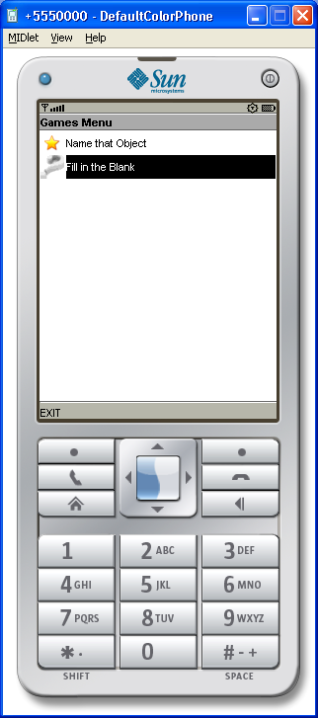

When the user selects a game he is presented with the following menu
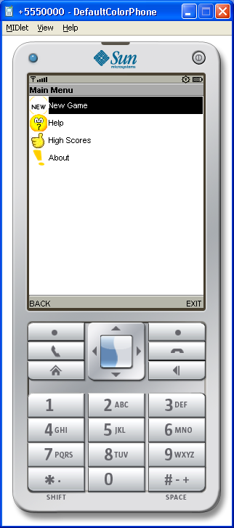
If the user selects Fill in the Blank and then New Game he is shown the following screen.
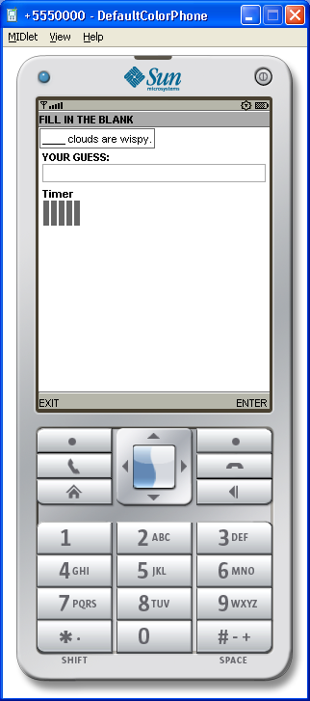

The user must enter his answer in the space provided and select Enter. If he is correct he is presented with another sentence otherwise the field for data input is cleared and he can retry. The Gauge object, Timer, lets him know much time is left. A Gauge shows the progress of an activity. A Timer keeps track of elapsed time and can be attached to a Gauge object.

If the user selects Name that Object and then New Game he is shown the following screen.
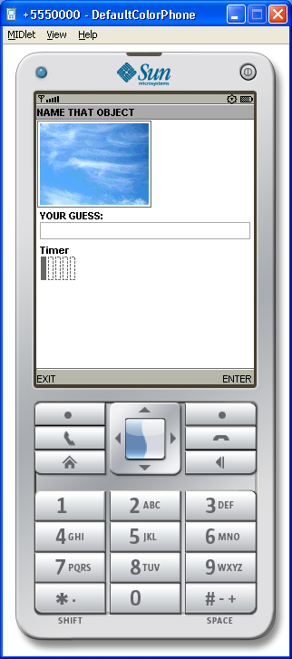

The user must enter his answer in the space provided and select Enter. If he is correct he is presented with another sentence otherwise the field for data input is cleared and he can retry. The Gauge object, Timer, lets him know much time is left.

When the user selects High Score on the Menu for a Game he is presented with the screen below.

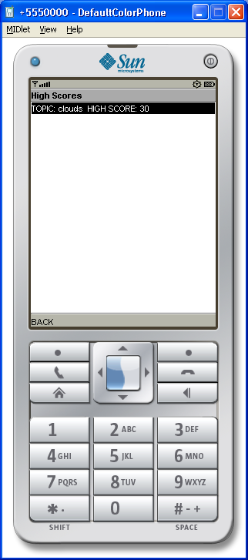

The highest score achieved by the user in each topic is saved. This can indicate to the user which are his stronger topics and which need more attention.

CONCLUSION
A mobile game has been developed that attempts to provide educational leisure during times when a user has a few minutes to spare. The application is flexible in that it can easily be applied to many subject areas and played by a wide age group. Lecturers can use this approach to feed short quizzes to students’ mobile phones.
Once a user has mastered a topic it is very likely that user will lose interest in the game. Future works will show how the game content can be modified by connecting to another device.
REFERENCES

Barnes, T., Richter, H., Powell, E., Chaffin, A., and Godwin, A. 2007. Game2Learn: building CS1 learning games for retention. SIGCSE Bull. 39, 3 (Jun. 2007), 121-125.
Bayliss, J. D. and Strout, S. 2006. Games as a "flavor" of CS1. SIGCSE Bull. 38, 1 (Mar. 2006), 500-504.

Beaubouef, T. and Mason, J. 2005. Why the high attrition rate for computer science students: some thoughts and observations. SIGCSE Bull. 37, 2 (Jun. 2005), 103-106.
Burd, B., Goulden, J., Ladd, B., Rogers, M., and Stewart, K. 2007. Computer games in the classroom, or, how to get perfect attendance, even at 8 AM. SIGCSE Bull. 39, 1 (Mar. 2007), 496-496.

Burd, B., Goulden, J., Ladd, B., Rogers, M., and Stewart, K. 2007. Computer games in the classroom, or, how to get perfect attendance, even at 8 AM. SIGCSE Bull. 39, 1 (Mar. 2007), 496-496.

Chamillard, A. T. 2006. Introductory game creation: no programming required. SIGCSE Bull. 38, 1 (Mar. 2006), 515-519.

Chao, C. 2006. An Investigation of Learning Style Differences and Attitudes toward Digital Game-based Learning among Mobile Users. In Proceedings of the 4th IEEE International Workshop on Wireless, Mobile and Ubiquitous Technology in Education (Nov. 16-17, 2006). WMTE. IEEE CS, Washington, DC, 29-31.

Claypool, K. and Claypool, M. 2005. Teaching software engineering through game design. SIGCSE Bull. 37, 3 (Sep. 2005), 123-127.

Classic game gets thumbs working worldwide. ”http://www.nokia.com/A4303014

Claypool, K. and Claypool, M. 2005. Teaching software engineering through game design. SIGCSE Bull. 37, 3 (Sep. 2005), 123-127.
Costabile, Maria F., De Angeli, Antonella, Lanzilotti ,Rosa, Ardito, Carmelo, Buono, Paolo, Pederson, Thomas. Explore! Possibilities and Challenges of Mobile Learning. CHI 2008, April 5–10, 2008, Florence, Italy. 145-154.
ELSPCA. Available at www.elspa.com.
International Conference Proceeding Series, vol. 223, 1-2.
Koivisto, E. M. 2006. Mobile games 2010. In Proceedings of the 2006 international Conference on Game Research and Development (Perth, Australia, Dec. 4-6, 2006). ACM
Koivisto, E. M. 2006. Mobile games 2010. In Proceedings of the 2006 international Conference on Game Research and Development (Perth, Australia, Dec. 4-6, 2006). ACM International Conference Proceeding Series, vol. 223, 1-2.
Koller, A., Foster, G., and Wright, M. 2008. Java Micro Edition and Adobe Flash Lite for arcade-style mobile phone game development: a comparative study. In Proceedings of the 2008 Annual Research Conference of the South African institute of Computer Scientists and information Technologists on IT Research in Developing Countries: Riding the Wave of Technology (Wilderness, South Africa, October 06 - 08, 2008). SAICSIT '08, vol. 338. ACM, New York, NY, 131-138.
Kurkovsky, Stan. 2009. Engagement: gaming throughout the curriculum. Technical Symposium on Computer Science Education. Proceedings of the 40th ACM technical symposium on Computer science Chattanooga, TN, USA .Pages 342-346.
Kurkovsky, Stan. 2009. Engaging students through mobile game development. Technical Symposium on Computer Science Education. Proceedings of the 40th ACM technical symposium on Computer science education, Chattanooga, TN, USA. Pages 44-48.
Morrison, Briana B., Peston, Jon. Engagement: gaming throughout the curriculum. 2009. Technical Symposium on Computer Science Education archive. Proceedings of the 40th ACM technical symposium on Computer science Chattanooga, TN, USA. Pages 342-346. Year of Publication: 2009 .

Nokia. Classic game gets thumbs working worldwide. http://www.nokia.com/A4303014. Accessed April 30th 2009.

Telephia. 2006. Puzzle/Strategy and Retro/Arcade Mobile Games are the Most Popular among U.K. 3G Subscribers. http://www.telephia.com/html/insights_071206.html

Yordanova, Korneliya. 2007. Mobile learning and integration of advanced technologies in education. In Proceedings of the 2007 international conference on Computer systems and technologies. 23(1)-23(6).

